 

**Cairo University**

**Faculty of Computers and Artificial Intelligence**

**Information Systems Department**

**Graduation Project Report**

**Graduates Guide**

By

|  |  |
| --- | --- |
| **Ziad Mohamed Samir** | **20200204** |
| **Ahmed Hossam Eldin Fadel** | **20200009** |
| **Islam Yasser Tamer** | **20200082** |
| **Ahmed Sayed Abdelfattah** | **20200018** |
| **Ahmed Mamdouh Mohamed** | **20200052** |
| **Aser Mohamed Maher** | **20200072** |

**Under the Supervision of**

**Dr. Sherif Mazen**

**TA. Esraa Salah**

*Department of Information Systems, Faculty of Computers and Artificial Intelligence, Cairo University, Egypt*

February 2024

**Acknowledgements**

We would like to thank all the contributors who helped accomplishing this project and developing it. Moreover, we would like to give an appreciation to Dr Sherif Mazen who supervised us during the process, taught us how to work as a team and how to manage a complete project lifecycle. Also, Eng Esraa Salah who guided us during the year and was always there when we needed her help. Finally, a big thank for all DRs, TAs and faculty board who taught us during this 4 years journey.

**Abstract**

We propose developing a website called “Graduates Guide”.  
The main goal of “Graduates Guide” is to help enhance the communication between “FCAI” and its Graduates. Both sides will have access to the website, the faculty administrators can manage the Graduates easily (including any paperwork regarding the graduates), communicate with them, announce for any new project opportunity, and perform analysis on the graduate’s data.  
Also graduates can manage their own profile and add any information about them, can apply for Masters and Ph.D., send requests to the faculty administrators, and communicate with other graduates that have a profile on the website.  
By the launch of the website, any work related to graduates affairs the faculty should complete it using the website and any paperwork graduates want to get should request for it from the website before going to the faculty.

**Table of Contents**

**Chapter 1**

1.1 Background and Motivation 6

1.2 Problem Statement 6

1.3 Objectives 6

1.4 Project Scope and Limitations 7

1.5 Project Methodology 8

1.6 Project Report Outline 9

**Chapter 2**

2.1 Comparison between our System and newecom System 10

**Chapter 3**

3.1 Functional Requiremnets 11

3.2 Non-Functional Requirements 13

3.3 Stakeholders and Technologies 14

3.4 Task Profile 15

3.5 Persona 16

3.6 System Architecture 17

3.7 ERD 18

3.8 UML Diagrams 19

3.8.1 Use Case Diagram 19

3.8.2 Use Case Description 20

3.8.2 Class Diagram 26

3.8.3 Sequence Diagram 31

3.8.4 Activity Diagram 37

**Chapter 4**

4.1 UI 42

**Chapter 5**

5.1 Testing 42

**List of Figures**

*Figure number Page Number*

Figure 1. Project Plan. 7

Figure 2. Waterfall model 9

Figure 3. User Persona 16

Figure 4. User Persona 16

Figure 5. User Persona 17

Figure 6. System Architecture 17

Figure 7. ERD 18

Figure 8. Use Case Diagram 19

Figure 9. Class Diagram 26

Figure 10,11. Snapshots from Class Diagram 27

Figure 12,13. Snapshots from Class Diagram 28

Figure 14,15. Snapshots from Class Diagram 29

Figure 16. Snapshots from Class Diagram 30

Figure 17. Add new Announcement (Sequence Diagram) 31

Figure 18. Analyze Graduates Data (Sequence Diagram) 32

Figure 19. Manage Profile (Sequence Diagram) 33

Figure 20. Apply for Job (Sequence Diagram) 34

Figure 21. Send a Request (Sequence Diagram) 35

Figure 22. Search for Graduate (Sequence Diagram) 36

Figure 23. Add new announcement (Activity Diagram) 37

Figure 24. Respond to a Request (Activity Diagram) 38

Figure 25. Announce new Project (Activity Diagram) 39

Figure 26. Print Certificate (Activity Diagram) 40

Figure 27. Add new graduate (Activity Diagram) 41

**List of Tables**

*Table number Page Number*

Table 1. Comparison between our website and newecom 12

Table 2. Task Profile 17

Table 3. Manage Profile Use Case Description 22

Table 4. Apply for Job Use Case Description 23

Table 5. Send a Request Use Case Description 24

Table 6. Make an announcement Use Case Description 25

Table 7. Send a Response Use Case Description 26

Table 8. announce new project Use Case Description 27

**List of Abbreviations**

|  |  |
| --- | --- |
| Abbreviation | Meaning |
| FCAI | Faculty of Computers and Artificial Intelligence |
| UI | User Interface |

# Introduction

* 1. Background and Motivation

Its important to have a system that links both graduates and faculty, this will benefit

Both sides. Faculty can communicate with graduates easily when needed and graduates can access services online and find information they search for.

* 1. Problem Statement

The faculty’s website “newecom” doesn’t support graduates of the old bylaw “before 2008” instead, all the work related to graduates of old bylaw is done manually through another old system and excel sheets which is time and effort consuming for the graduates’ department employees.  
also, any graduates’ related service is done offline, there are no automated services for the graduates. Which make it difficult for both faculty and graduates to communicate to complete their work and services respectively.

* 1. Objectives
* Add the features that allow faculty administrator to manage graduates (add new graduate, update existing graduate, search, print paperwork) within the next three months.
* Add the features that allow faculty administrator to make an announcement within the next three months.
* Add the features that allow faculty administrator to analyze graduates’ data and track graduates within the next three months.
* Add the features that allow graduate to manage his own profile within the next four months.
* Add the features that allow graduate to send a request whether to get a paperwork or to apply for Masters or Ph.D. within the next five months.
* Add the features that allow graduate to apply for the job opportunities that the faculty administrators announce within the next five months.

* 1. Project Scope and Limitations

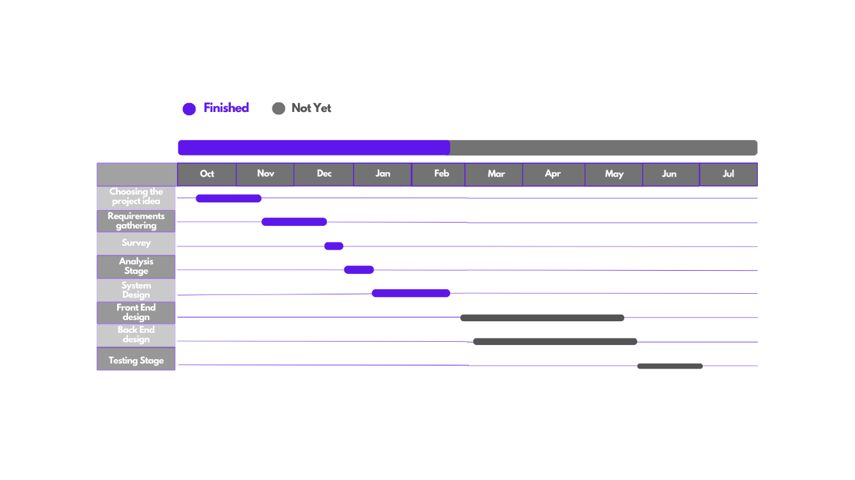The project mainly covers the graduates of “FCAI” and all work related to them whether it is from the faculty side or from the graduates’ side. The project is not concerned with undergraduates’ students.  
The project connects the faculty with its graduates, offers new features for the faculty administrators and involve the graduates of the faculty in the website.  
  
The technologies that we will use are the following:  
for Backend: **Node Js** as it provides packages that will help us implement the websitefor Frontend: **React Js** as it can be easily integrated with Node js  
for Database: **MySQL** as it provide various security features such as encryption and authentication, also our system requires a structured data model with well-defined relationships between entities.  
  
The data that we collected is other students and graduates opinions about what problems they face and what features they wish it exists and this data was collected through observations, also we asked faculty employees about what problems they face in their work.  
  
Our design is tested through asking students and graduates about their opinions and whether it is easy to use or not.

**Figure 1. Project Plan**

* 1. Project Methodology

Used Methodology: **Waterfall**

As the requirements of the project is well known and will not change, we thought that there is no need to use Agile. So, we decided to use Waterfall.

The Waterfall methodology works in 5 stages:

* **Requirements Analysis:**  
   in this stage we collect the users’ requirements, understand it well and perform analysis on it. And this stage is very important as there is no coming back, once we finished this stage and moved to the design stage the requirements is supposed to be understood well
* **Design:**

In this stage we work on the collected requirements. We identify the design

Of the application components, databases, and user interface. This stage is very important as the design created must include all the functionalities and meet all the requirements specified because this is the design that will be implemented in the next stage and there will be no modification.

* **Implementation:**

In the implementation stage the design created in the design stage is

Implemented. All the features of the system are implemented, so, after the implementation stage all the functionalities of the system should be working properly.

* **Testing:**

In this stage all the implemented features must be tested and we must be sure

That we meet all the users’ requirements, and the user experience also must be tested

To be sure that the users will be able to use the system. So, we perform these types

Of testing Unit Testing, Integration Testing, and Usability Testing.

* **Deployment:**

Once we are sure that all the function and non-functional requirements are

Met, then the system is ready to be deployed.

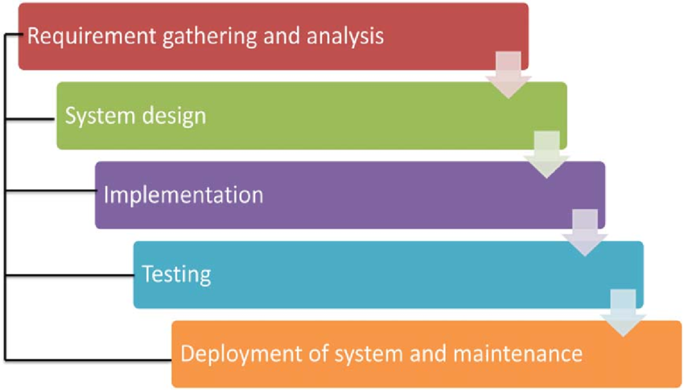

Waterfall Model

* 1. Project Report Outline

This section demonstrates the documentation outline as follows:

- Chapter 2 We will provide a comparison between our website and “FCAI” newecom  
to display the difference between the two solutions.

- Chapter 3 in this chapter, all the functional and non-functional requirements are displayed, in addition to, system analysis such as use case diagrams, use case descriptions, sequence diagrams, class diagrams, and activity diagrams.

- Chapter 4 We will provide the website UI design with all of its pages and how the functionalities will be used in the website.

# Market and Literature Survey

* 1. Comparison between our system and ecom old system

Existing similar websites:   
 ecom.cu.edu.eg

|  |  |  |
| --- | --- | --- |
| Features | newecom | Graduates guide |
| Add graduate (new bylaw) |  |  |
| Add graduate (old bylaw) |  |  |
| Edit graduate |  |  |
| Search for graduate |  |  |
| Print certificates Arabic and English |  |  |
| Graduate side |  |  |
| Certificate request |  |  |
| Apply for job |  |  |
| Announce new project |  |  |
| Analyzing graduates data |  |  |
| Sending & receiving notifications |  |  |
| Manage profile |  |  |
| Apply for Masters & ph.D. |  |  |
| Informative home page |  |  |

# <Graduates Guide> Analysis

* 1. Functional requirements
     1. **Registration:**  
        Super Admin and Administrator can register a new user and set his role on the website.
     2. **Log in:**

Any user registered on the website can log in to the website.

* + 1. **Log out:**

Any user registered on the website can log out from the website.

* + 1. **Reset Password:**

Any user registered on the website can change his password.

* + 1. **Delete Account:**

Super Admin and Administrator can have access to the delete account feature.

* + 1. **Manage Profile:**

Graduate can manage his own profile only, Administrator, and Super Admin can manage any profile registered on the website.

* + 1. **Add New Graduate:**

Super Admin and Administrator can add new graduate student to the database.

* + 1. **Update Existing Graduate:**

Super Admin and Administrator can update information of existing graduate.

* + 1. **Search for Graduates:**

Super Admin and Administrator can search for graduates by their id or by their department id.

* + 1. **Print:**

Super Admin and Administrator can print any paperwork (Certificate, statement, curriculum, grades report) for the graduates.

* + 1. **Track Graduates:**

Super Admin and Administrator can have access to the track graduates feature which allows the admin to track the graduate’s career path since graduation.

* + 1. **Analyze Graduates Data:**

Super Admin and Administrator can perform analysis on the graduate’s data to get information such (most worked track by department, hired percentage of all graduates of specific year, hired percentage of graduates of specific department of specific year).

* + 1. **Make an Announcement:**

Super Admin and Administrator can make an announcement that will be visible to all accounts registered on the website.

* + 1. **Apply for Masters and Ph.D.:**

Graduates can apply for Masters and Ph.D. by filling a form.

* + 1. **Apply for Job:**

Graduates can apply for a project that the administrators announce for.

* + 1. **Send a Request:**

Graduates can send a request to the Administrators to extract a certificate.

* 1. non-functional requirements
     1. **Security:**

All data inside the system must be protected against malware attacks and unauthorized users, and any graduate can’t access any other graduate’s data.

* + 1. **Scalability:**

The system can accommodate large number of users, data, or transactions without sacrificing performance or functionality.

* + 1. **Usability:**

-The website is easy to learn, a new user is able to use all the functionalities within the website easily.

-User friendly design.

-In case of error the, the website provides an explanation about what caused the error so that the user can fix his input.

* + 1. **Performance:**

-The website should perform well, for example, the response time when a user click shouldn’t exceed five seconds.

-Also, throughput, the website should be able to handle 100 transaction per second.  
-Data is retrieved within almost three seconds.

-The system can be scaled up or down to handle more requests.

# stakeholders

**Internal Stakeholders  
 Owners:** “FCAI” is a direct primary stakeholder which has the full responsibility of the website

**Employees:** employees are the faculty administrators who will be responsible for the work that   
 will be accomplished throughout the websiteand will have direct communication  
 with the customers whom are the graduates.

**Developers:** The team who is responsible for implementing, testing and maintaining the system.

**External Stakeholders  
 Graduates:** Graduates are direct primary stakeholders; they are the faculty graduates  
 who will use the graduates side functionalities of the website.

# Technology

**Frontend:** React Js, Bootstrap, jQuery, and Material UI  
 **Backend:** Node Js, Express and Docker  
 **Database:** MySQL

**Task Profile**

|  |  |  |  |
| --- | --- | --- | --- |
| Task | Super Admin | Admin | Graduate |
| Add Graduate |  |  |  |
| Update Graduate |  |  |  |
| Search for Graduate |  |  |  |
| Print Paperwork |  |  |  |
| Announcement a job |  |  |  |
| Announcement |  |  |  |
| Track graduate |  |  |  |
| Add bylaw |  |  |  |
| Analysis |  |  |  |
| Register Admin |  |  |  |
| Apply for job |  |  |  |
| Apply for master and Ph.D. |  |  |  |
| Manage profile |  |  |  |
| Send request |  |  |  |

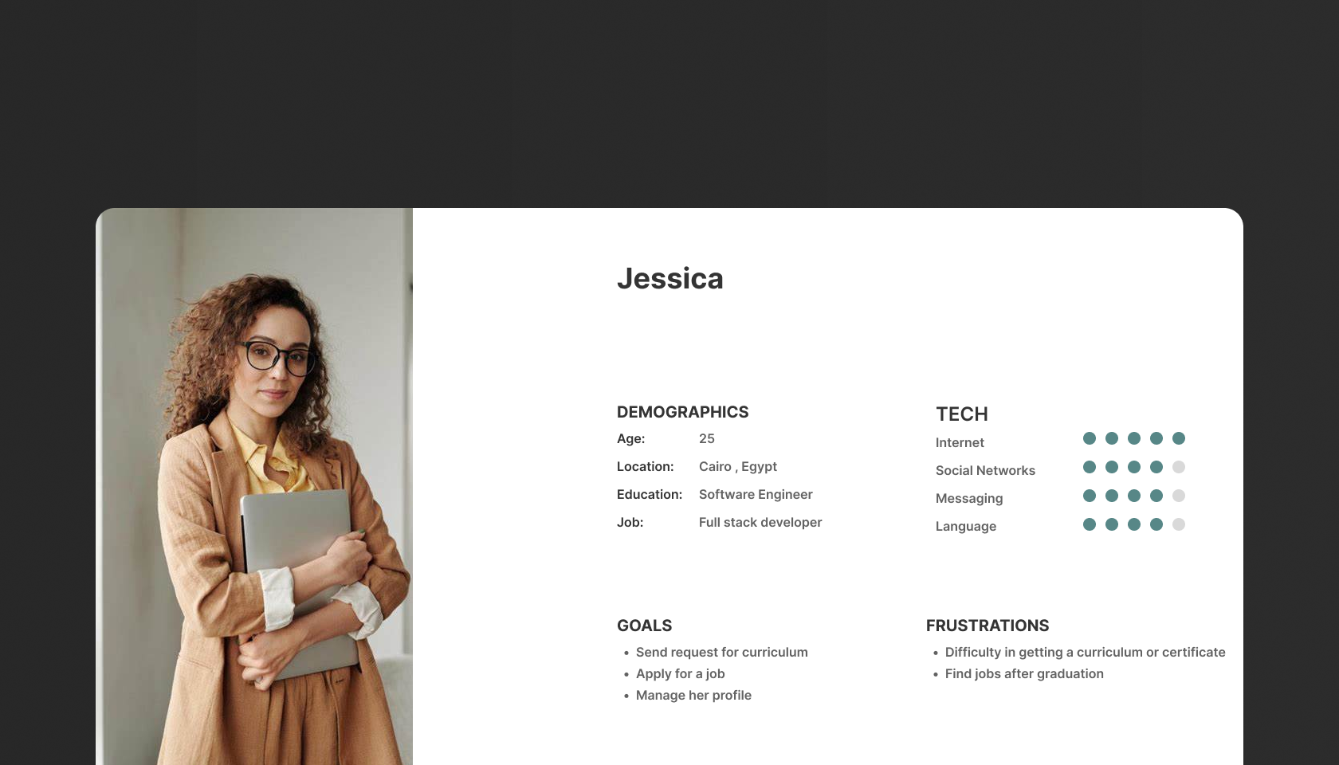**Persona**

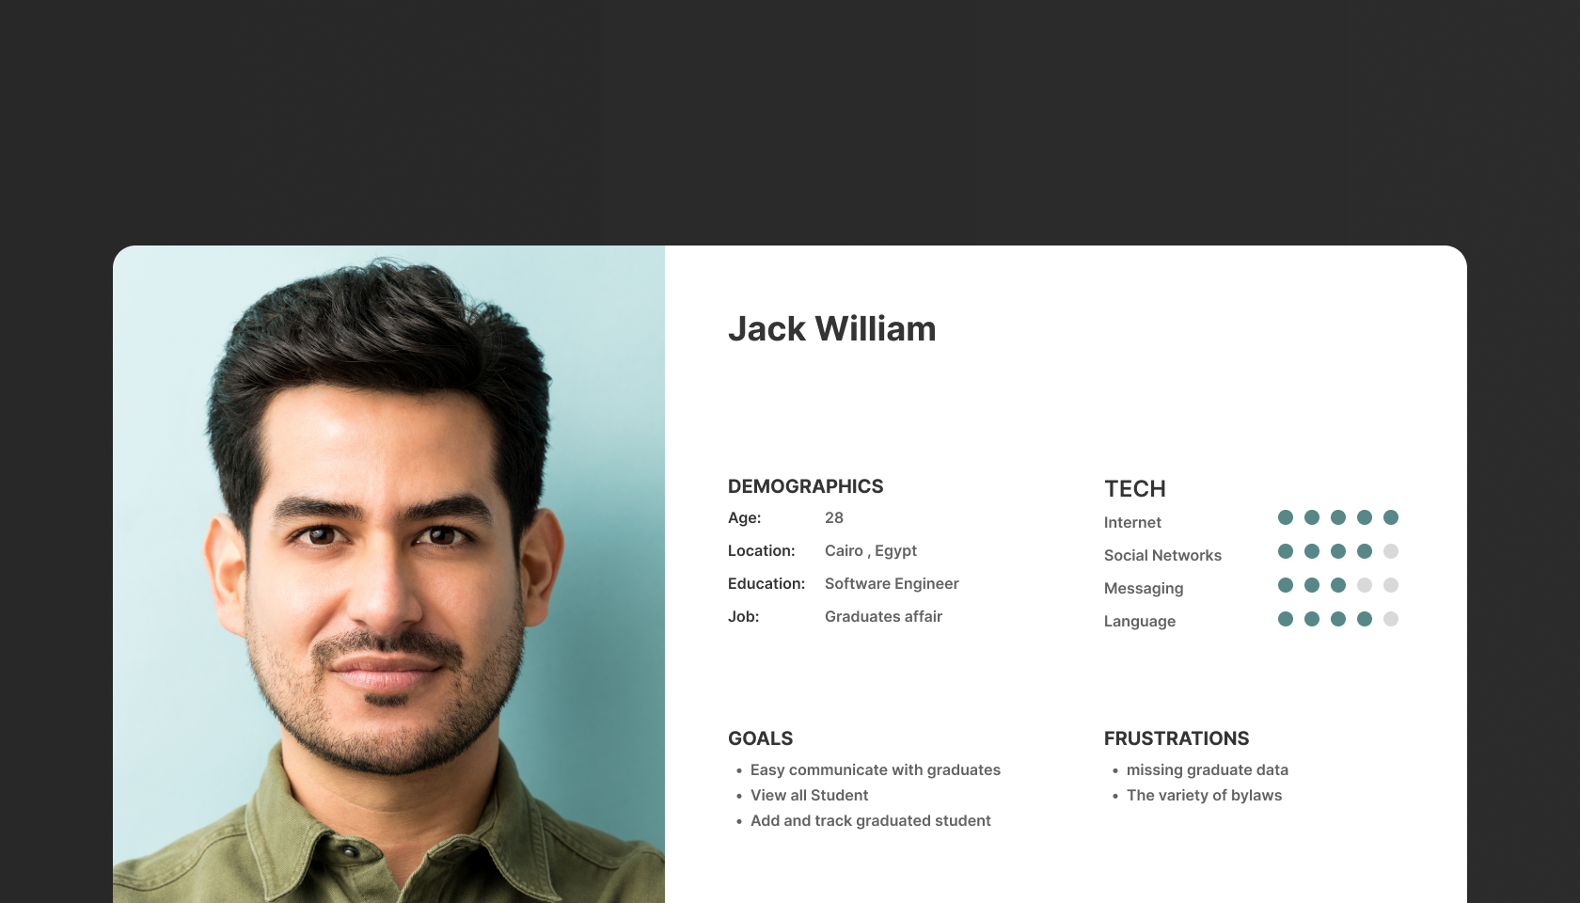

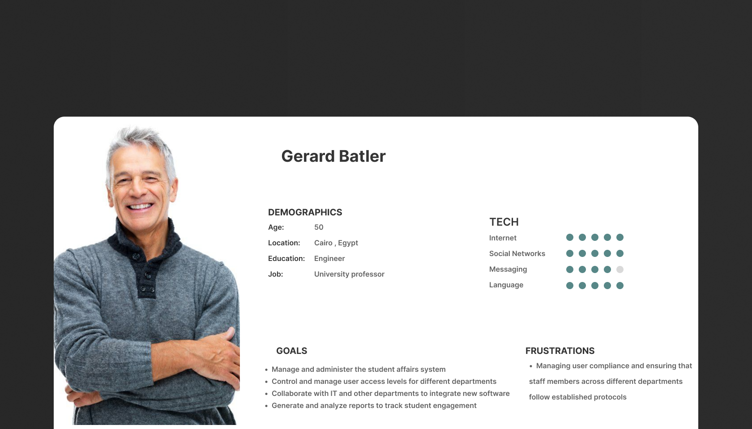

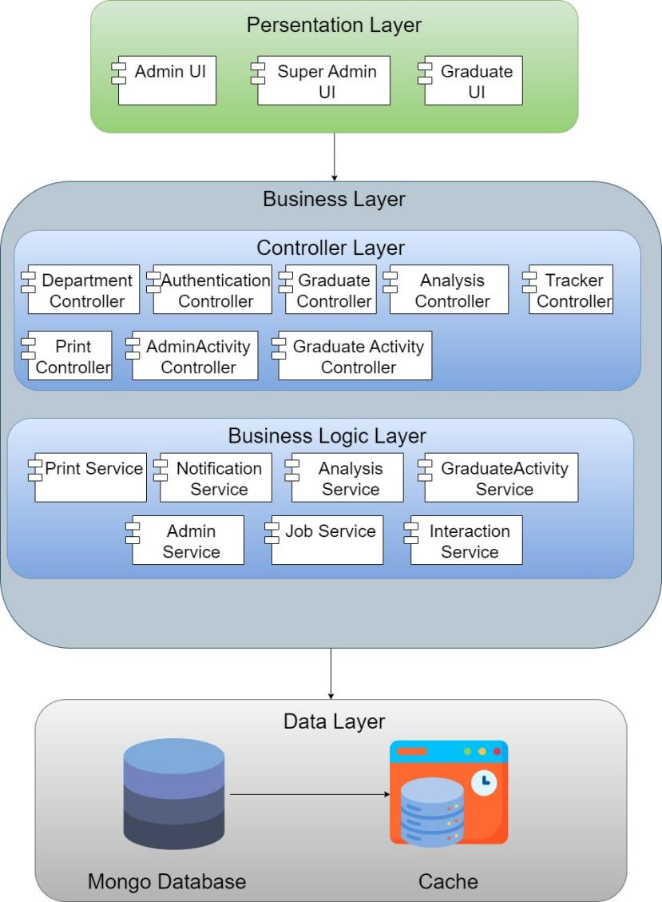**System Architecture**

**Erd Diagram**

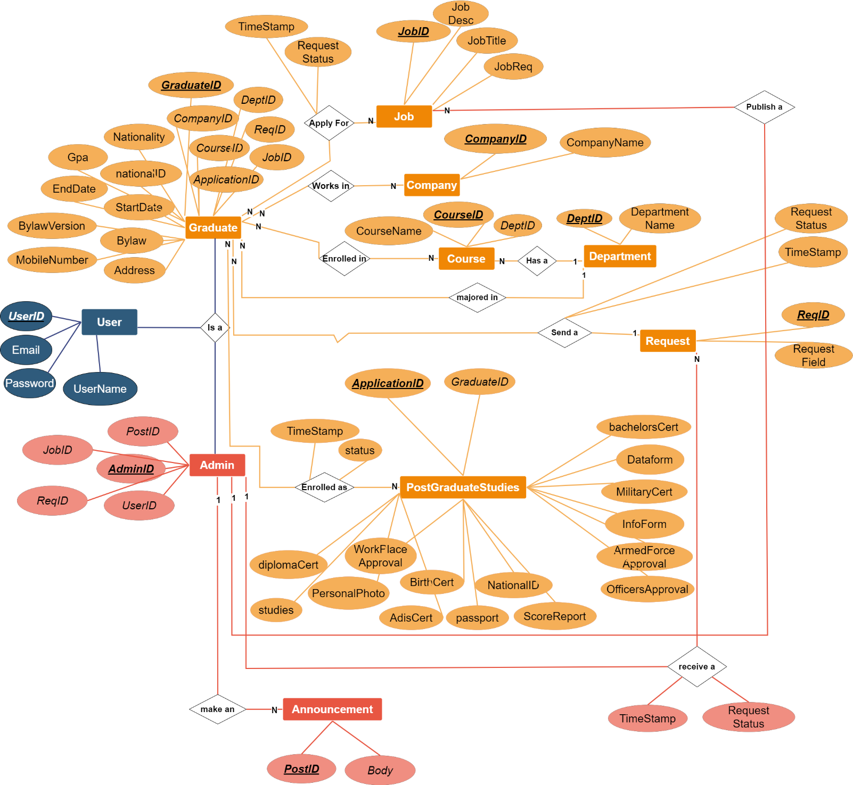

# uml diagrams

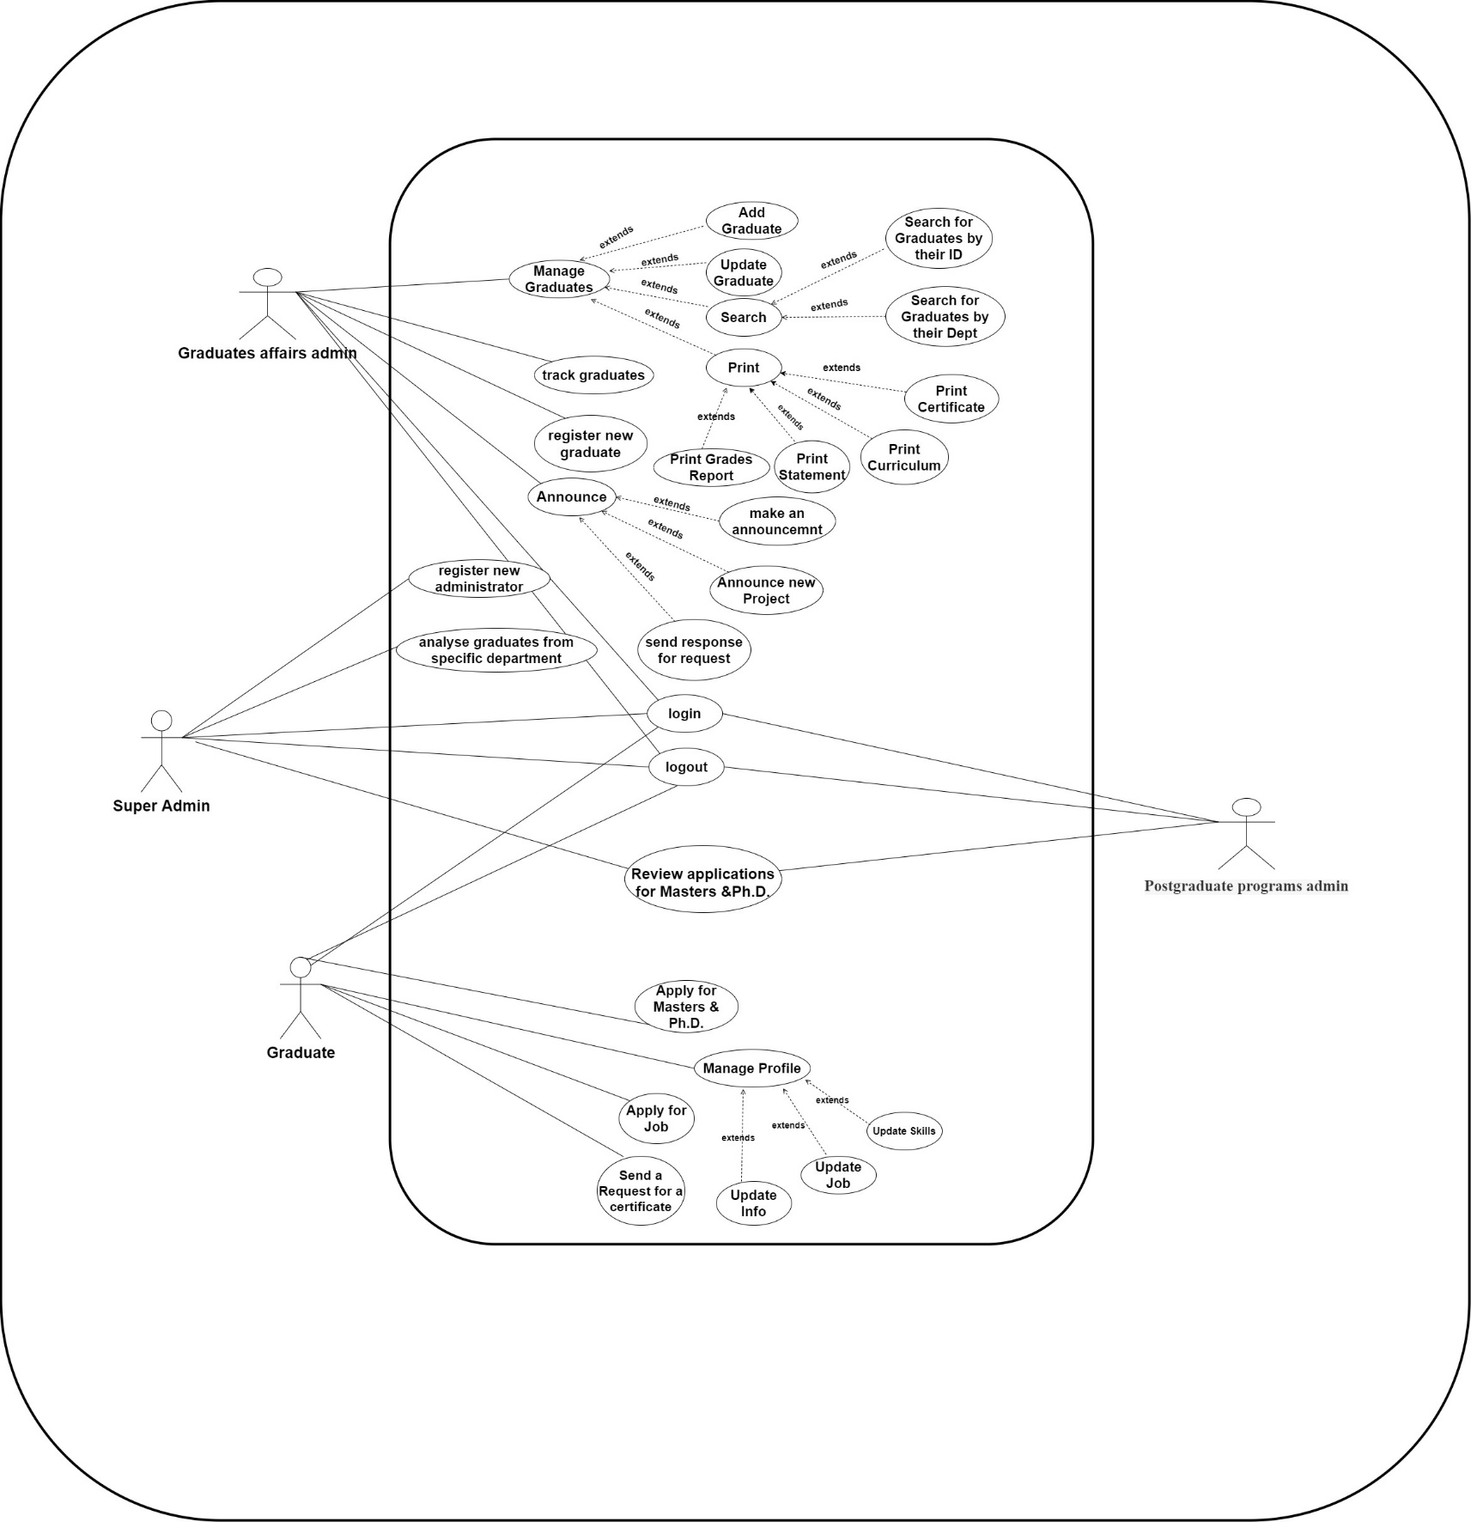**Use Case Diagram**

**Manage Profile Use Case description**

|  |  |  |
| --- | --- | --- |
| Use Case ID: | 01 | |
| Use Case Name: | Manage Profile | |
| Actors: | Graduate user | |
| Pre-conditions: | Graduate user logged in | |
| Post-conditions: | Data updated successfully | |
| Flow of events: | **User Action** | **System Action** |
| The graduate logged in |  |
|  | system authorized the login data |
| The graduate navigated to his profile to update his info |  |
|  | A page appears to the user including his data he wants to update |
| The graduate updates the authorized data he can update like (his photo , his current job….etc) |  |
|  | The page will be updated with the new user data |
|  | System saves the updated data to database and send pop up with accepted |
| Exceptions: | **User Action** | **System Action** |
| User updates unauthorized data like  (his gpa , graduated year…etc) |  |
|  | System sends a pop up to notify the user that it is not authorized to update this field |
| Includes: | * login | |
| Notes and Issues: | None | |

|  |  |  |
| --- | --- | --- |
| Use Case ID: | 03 | |
| Use Case Name: | Apply For Job | |
| Actors: | Graduate user | |
| Pre-conditions: | Graduate user logged in | |
| Post-conditions: | Graduate user cv uploaded successfully | |
| Flow of events: | **User Action** | **System Action** |
| The graduate logged in |  |
|  | system authorized the login data |
| The graduate navigated to university projects page to see the available jobs |  |
|  | A page appears to the user including the available projects and job needed with the needed skills |
| The graduate applies for the suitable job and suitable skills required |  |
|  | A page appears to the user including the data required about the user and ask him for his cv |
| The graduate fills the required field and uploads his cv |  |
|  | System saves the uploaded data and cv to database and sends pop up to notify the user to wait for the response |
| Exceptions: | **User Action** | **System Action** |
| The graduate navigated to university projects page to see the available jobs |  |
|  | A page shows that no projects available now |
| Includes: | * login | |
| Notes and Issues: | None | |

**Apply for Job Use Case Description**

**Send a request for Certificate Use Case Description**

|  |  |  |
| --- | --- | --- |
| Use Case ID: | 02 | |
| Use Case Name: | Send Request For Certificate | |
| Actors: | Graduate user | |
| Pre-conditions: | Graduate user logged in | |
| Post-conditions: | Request Sent to the admin | |
| Flow of events: | **User Action** | **System Action** |
| The graduate logged in |  |
|  | system authorized the login data |
| The graduate navigated to requests page |  |
|  | A page appears to the user and ask him to enter the name, id and type of request |
| The graduate enters his info and req type and send the request by send button |  |
|  | System sends pop up that the request sent successfully to the admin and tills him to wait for the response data from the admin soon |
| Exceptions: | **User Action** | **System Action** |
| - |  |
|  | - |
| Includes: | * login | |
| Notes and Issues: | None | |

**Make an announcement Use Case Description**

|  |  |  |
| --- | --- | --- |
| Use Case ID: | 12 | |
| Use Case Name: | Announce for Graduates | |
| Actors: | Administrator | |
| Pre-conditions: | Faculty has new announcement | |
| Post-conditions: | Announcement has been sent to graduates and saved to Database | |
| Flow of events: | **User Action** | **System Action** |
| Administrator logged in |  |
|  | Ssystem authorized the login data |
| Administrator navigated to add announcement for graduates |  |
|  | System navigates for page with form fields for announcement |
| Administrator fills form |  |
|  | Successful alerts with successful message |
| Exceptions: | **User Action** | **System Action** |
| Administrator logging in with wrong credentials |  |
|  | System alerts there is wrong credentials |
| Includes: | 1. Login | |
| Notes and Issues: | ــــــــــــــــــــــــــــــــــــــــــــــــــــــــــــــــــــــــــــــــ | |

**Send a response for request Use Case Description**

|  |  |  |
| --- | --- | --- |
| Use Case ID: | 10 | |
| Use Case Name: | Send Response for Request | |
| Actors: | Administrator | |
| Pre-conditions: | Graduate requested for Certificate | |
| Post-conditions: | Send Request Status | |
| Flow of events: | **User Action** | **System Action** |
| Administrator logged in |  |
|  | System authorized the login data |
| Administrator navigated to requests page |  |
|  | System navigates to a page appears with all certificate requests |
| Administrator responses for graduate request |  |
|  | Response will be sent to graduate |
| Exceptions: | **User Action** | **System Action** |
| Administrator logging in with wrong credentials |  |
|  | System alerts there is wrong in credentials |
| Includes: | 1. Login | |
| Notes and Issues: | ــــــــــــــــــــــــــــــــــــــــــــــــــــــــــــــــــــــــــــــــ | |

**Announce for new Project Use Case Description**

|  |  |  |
| --- | --- | --- |
| Use Case ID: | 11 | |
| Use Case Name: | Announce for new project | |
| Actors: | Administrator | |
| Pre-conditions: | Faculty has project and wants graduates | |
| Post-conditions: | Announcement has been sent to graduates and saved to Database | |
| Flow of events: | **User Action** | **System Action** |
| Administrator logged in |  |
|  | System authorized the login data |
| Administrator navigated to add announcement for new project |  |
|  | System navigates for page with form fields with project description and details |
| Administrator fills form |  |
|  | Successful alerts with successful message |
| Exceptions: | **User Action** | **System Action** |
| Administrator logging in with wrong credentials |  |
|  | System alerts there is wrong credentials |
| Includes: | 1. Login | |
| Notes and Issues: | ــــــــــــــــــــــــــــــــــــــــــــــــــــــــــــــــــــــــــــــــ | |

**Class Diagram without attributes**

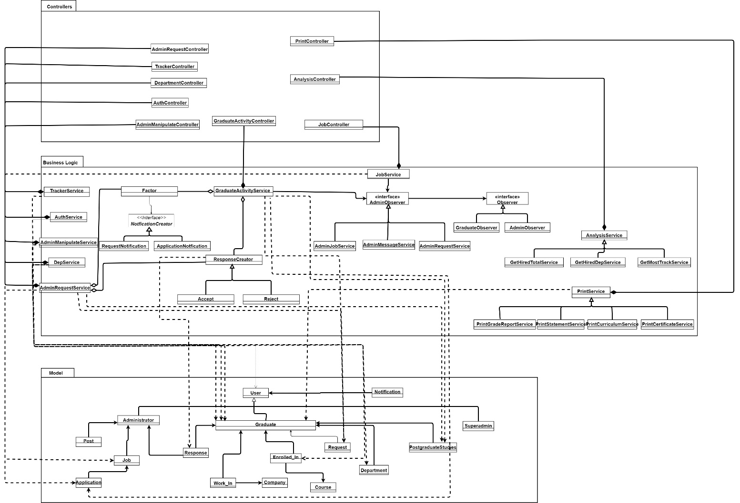

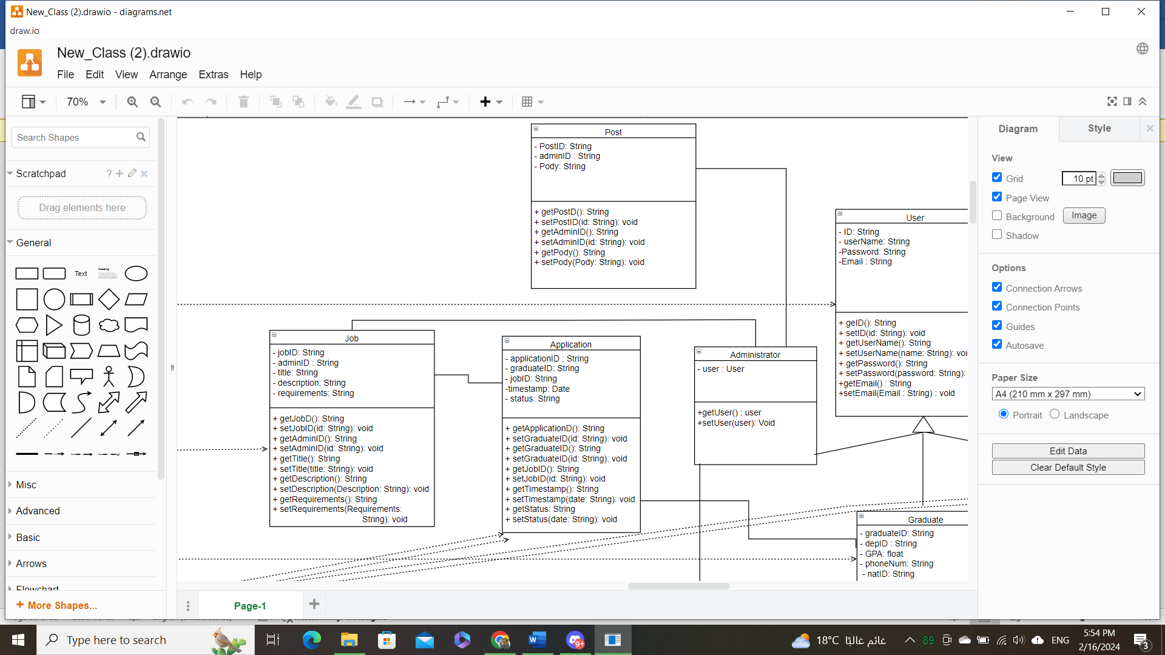**Snapshots from class diagram with attributes**

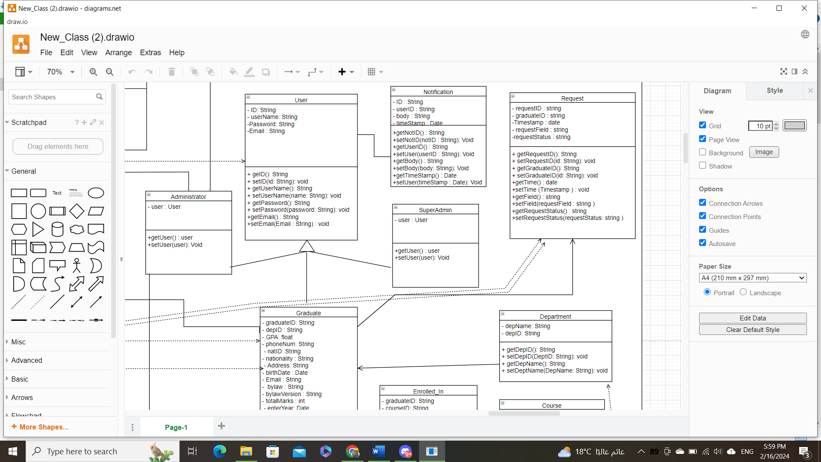

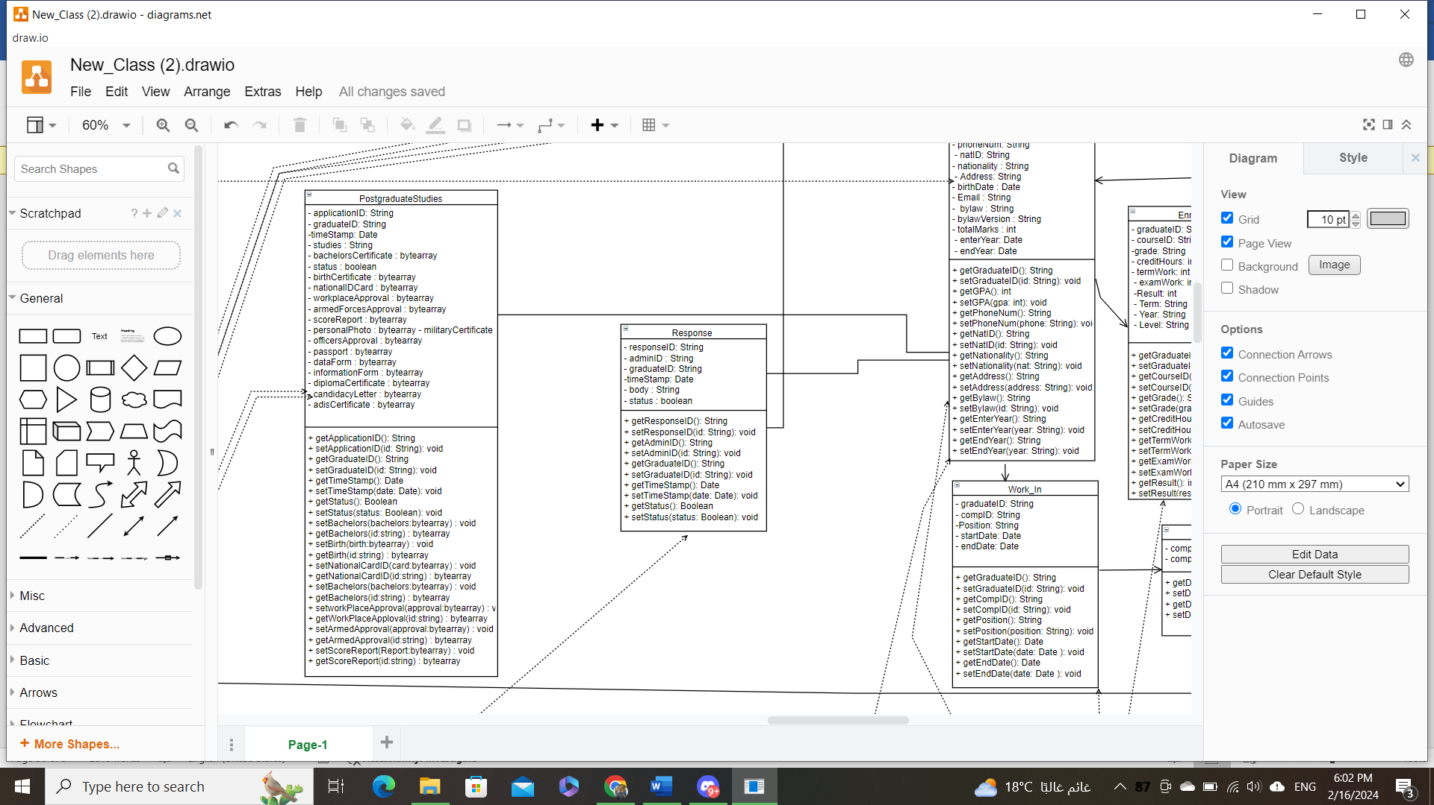

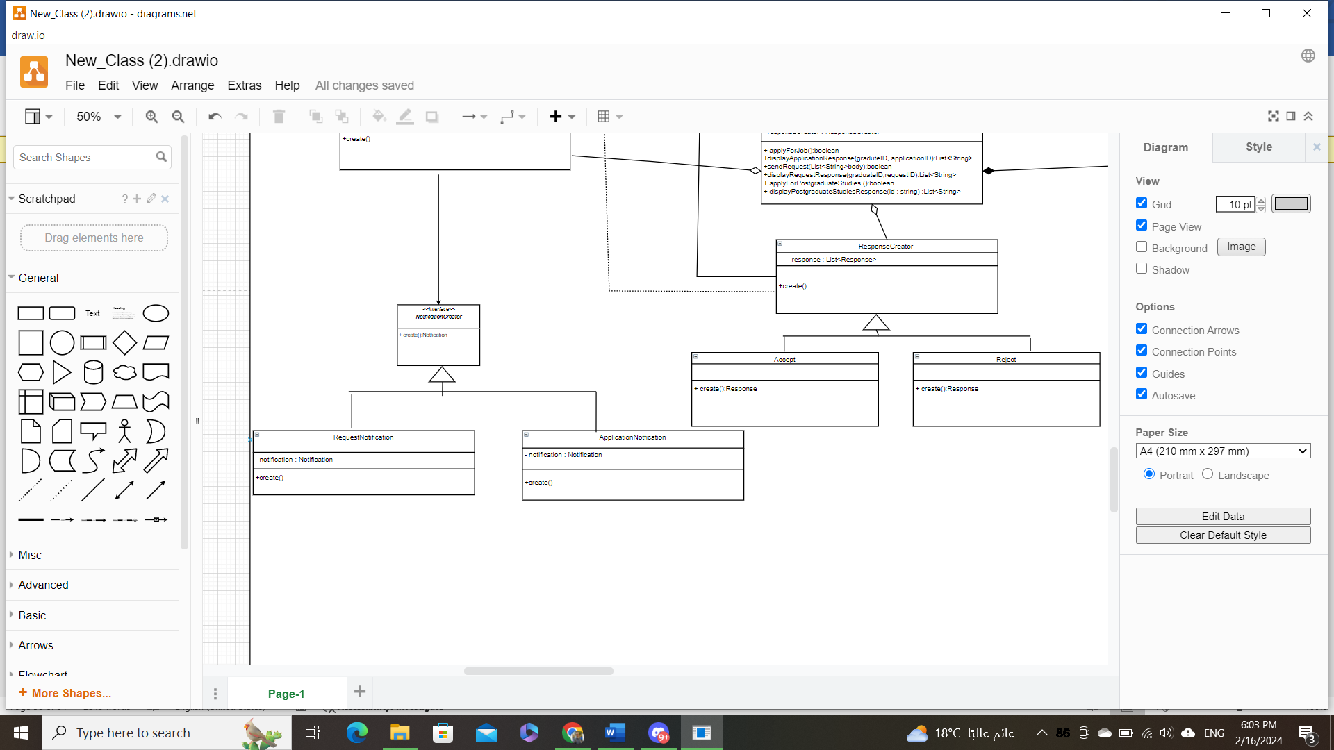

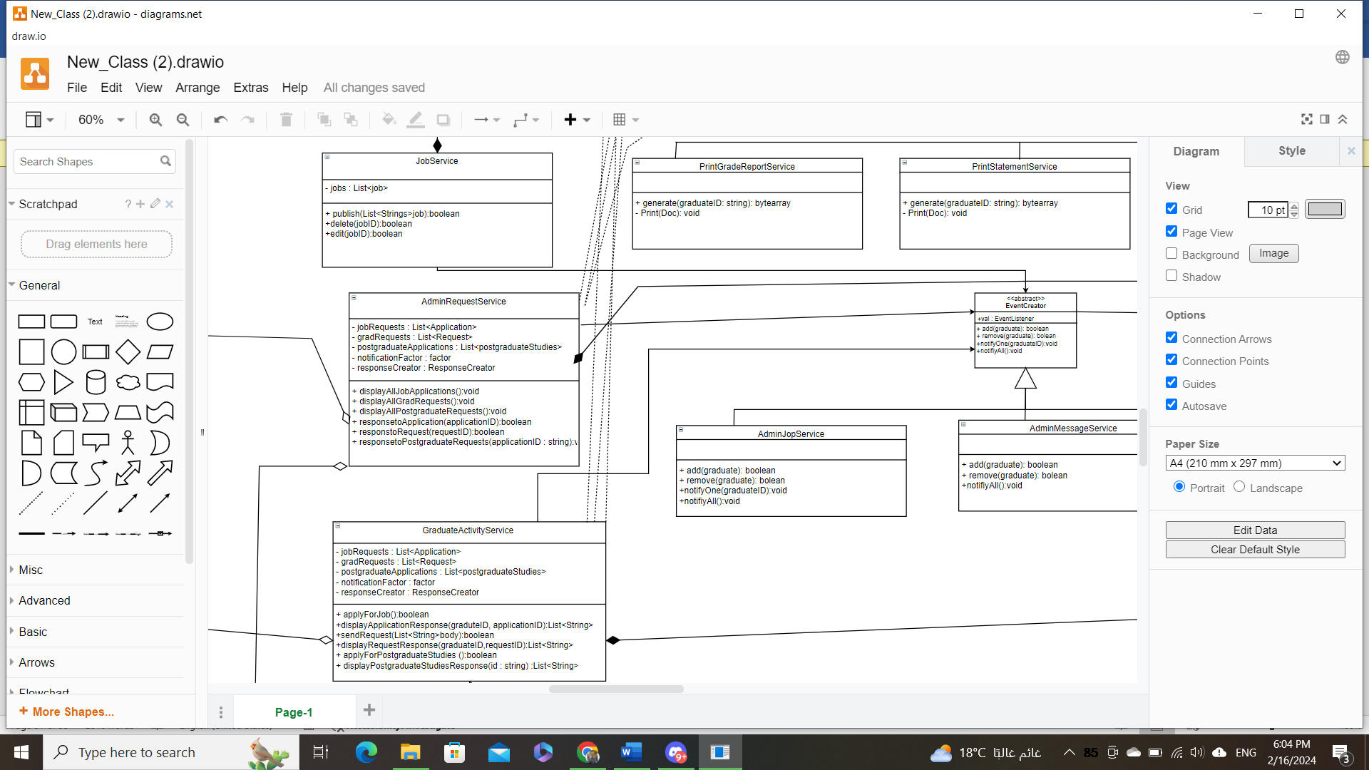

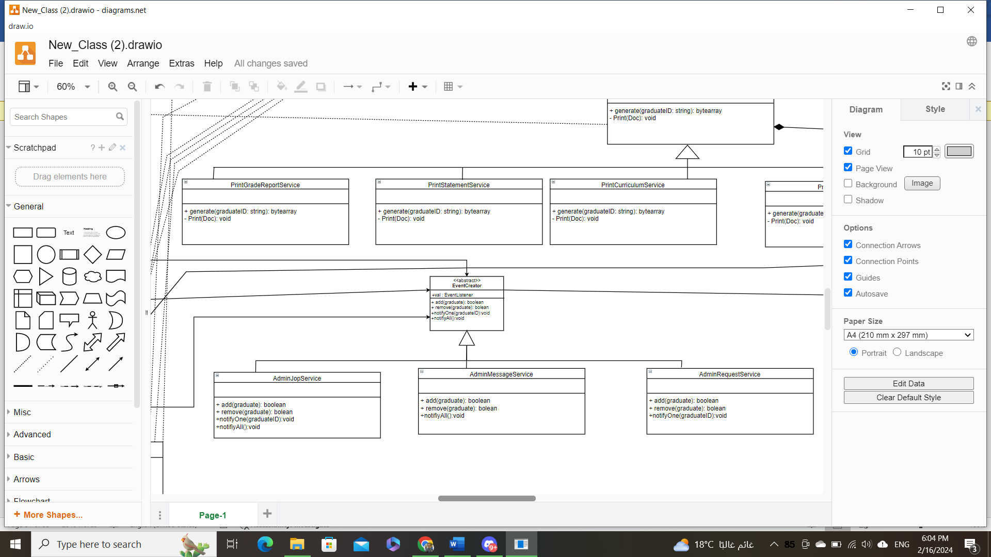

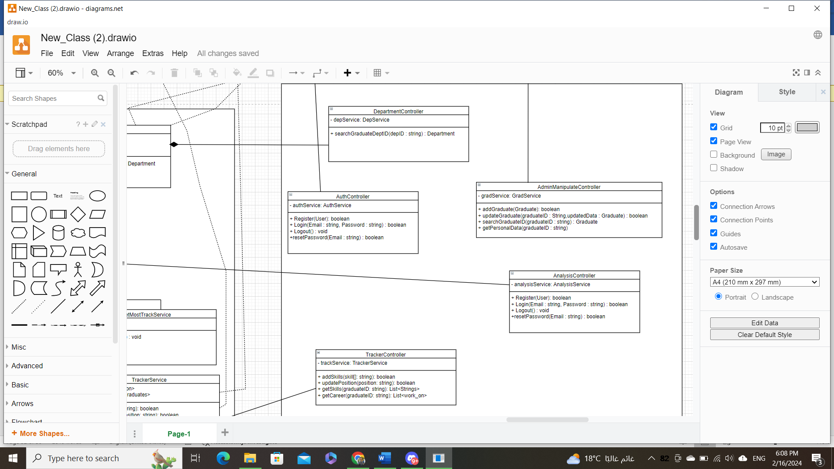

**Sequence Diagram**

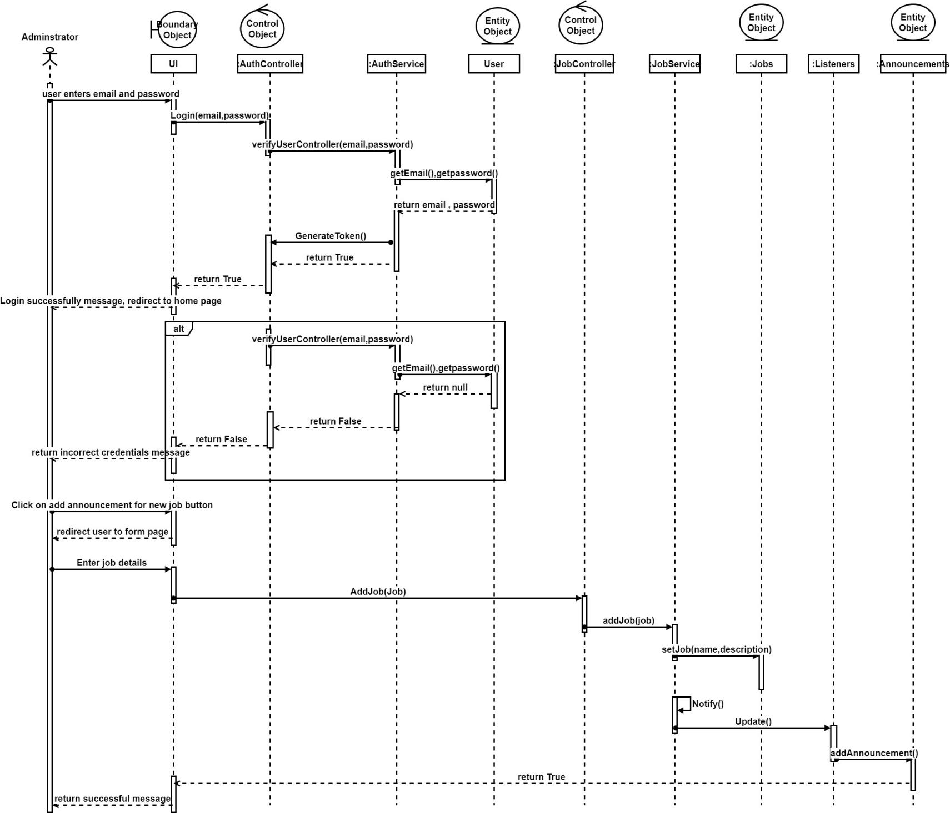Add new announcement

**Analyze Graduates data**

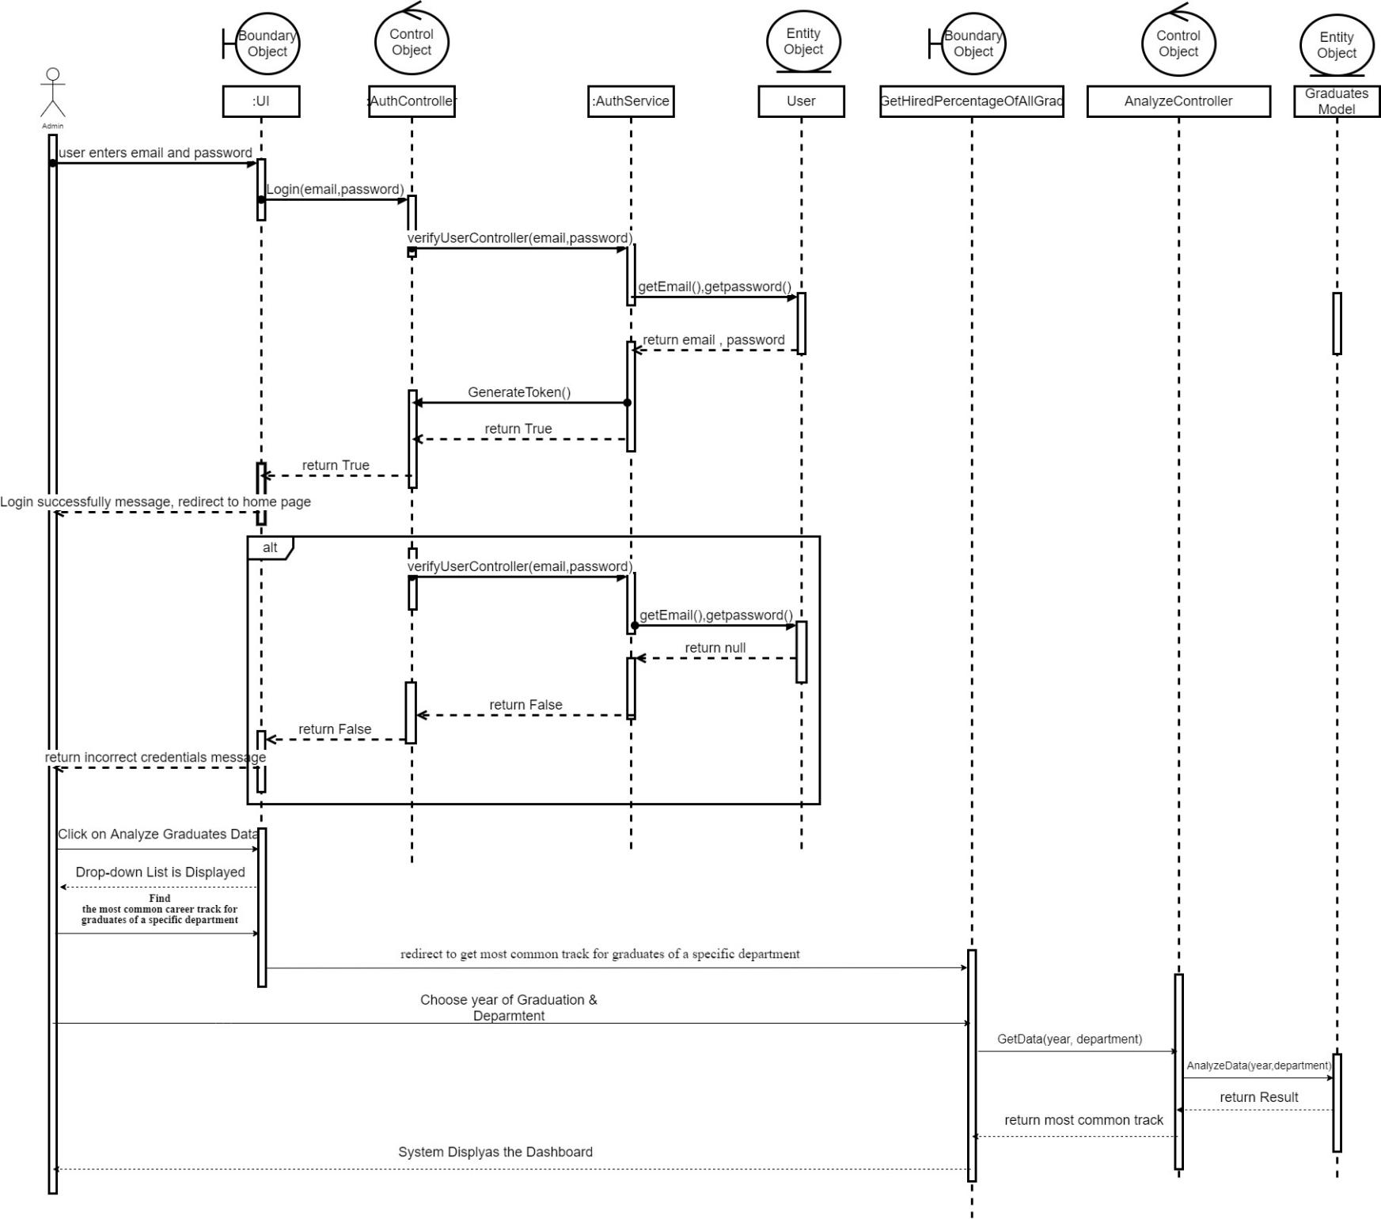

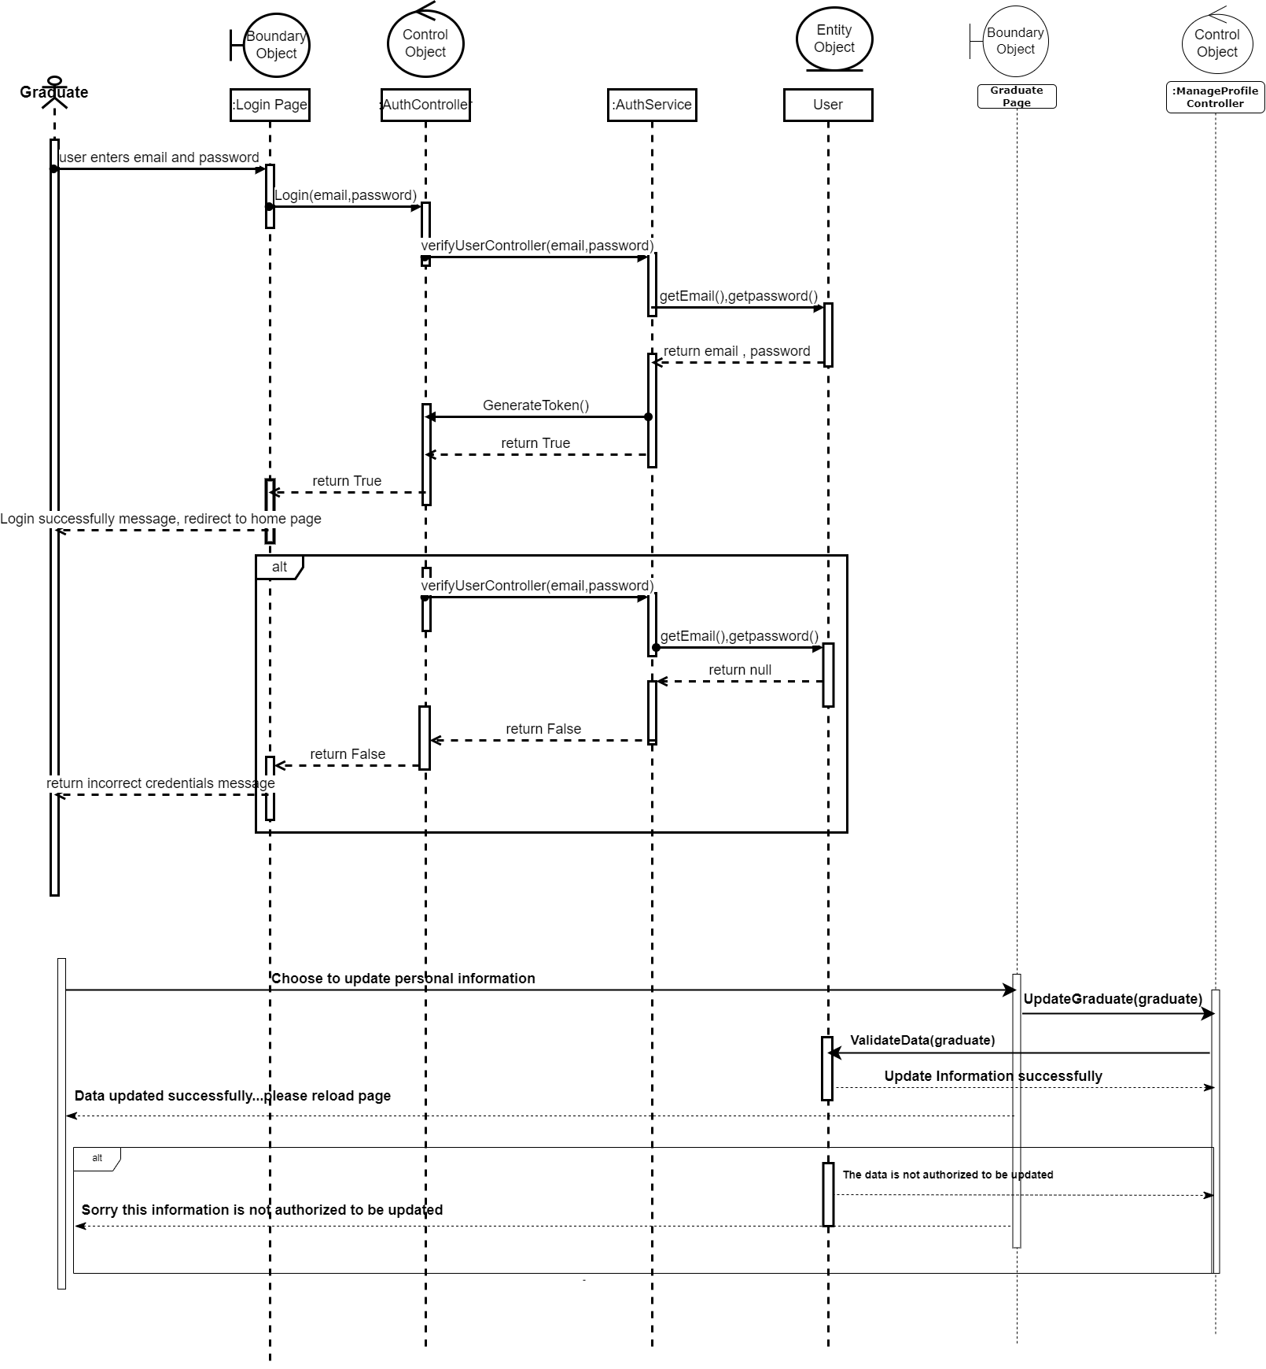**Manage Profile**

**Apply for job**

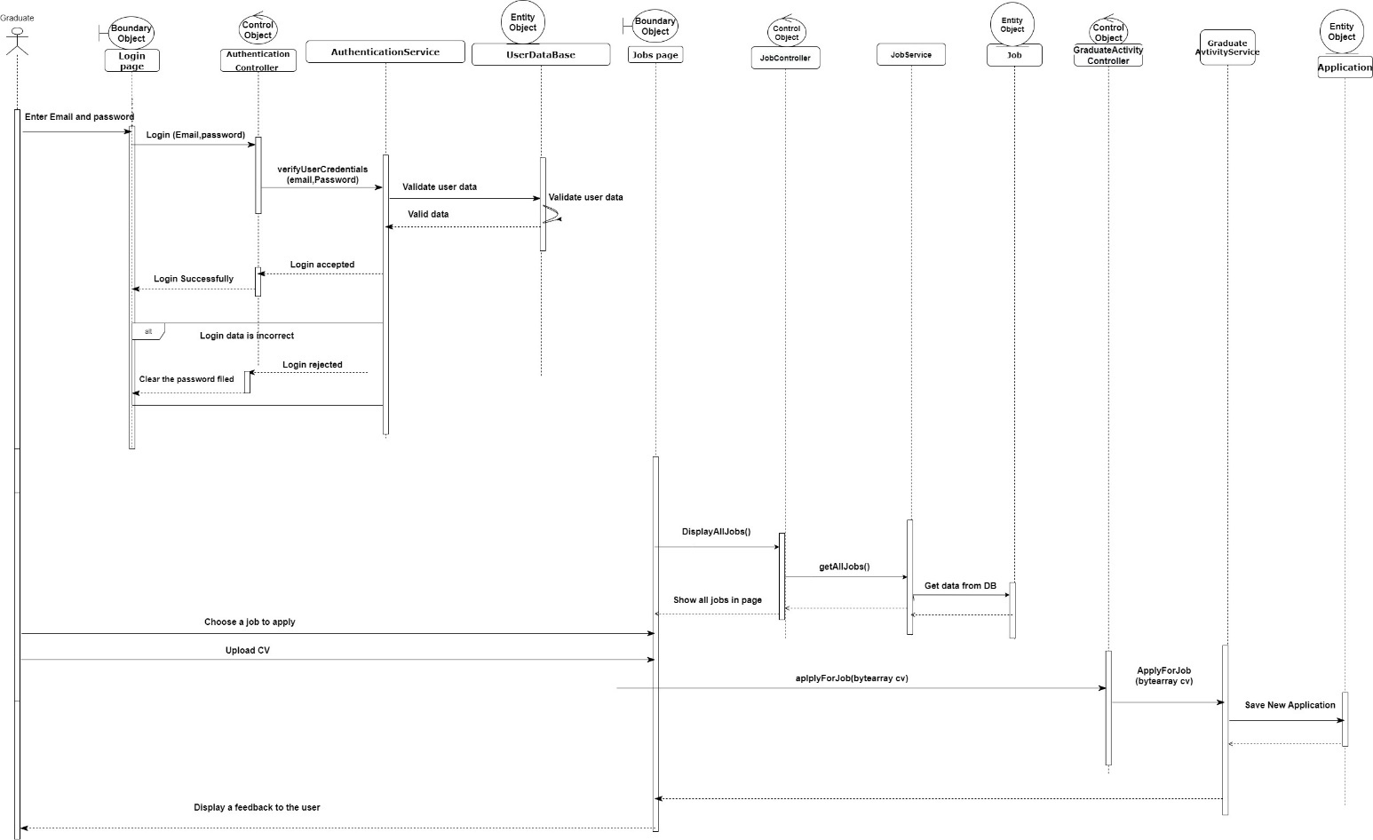

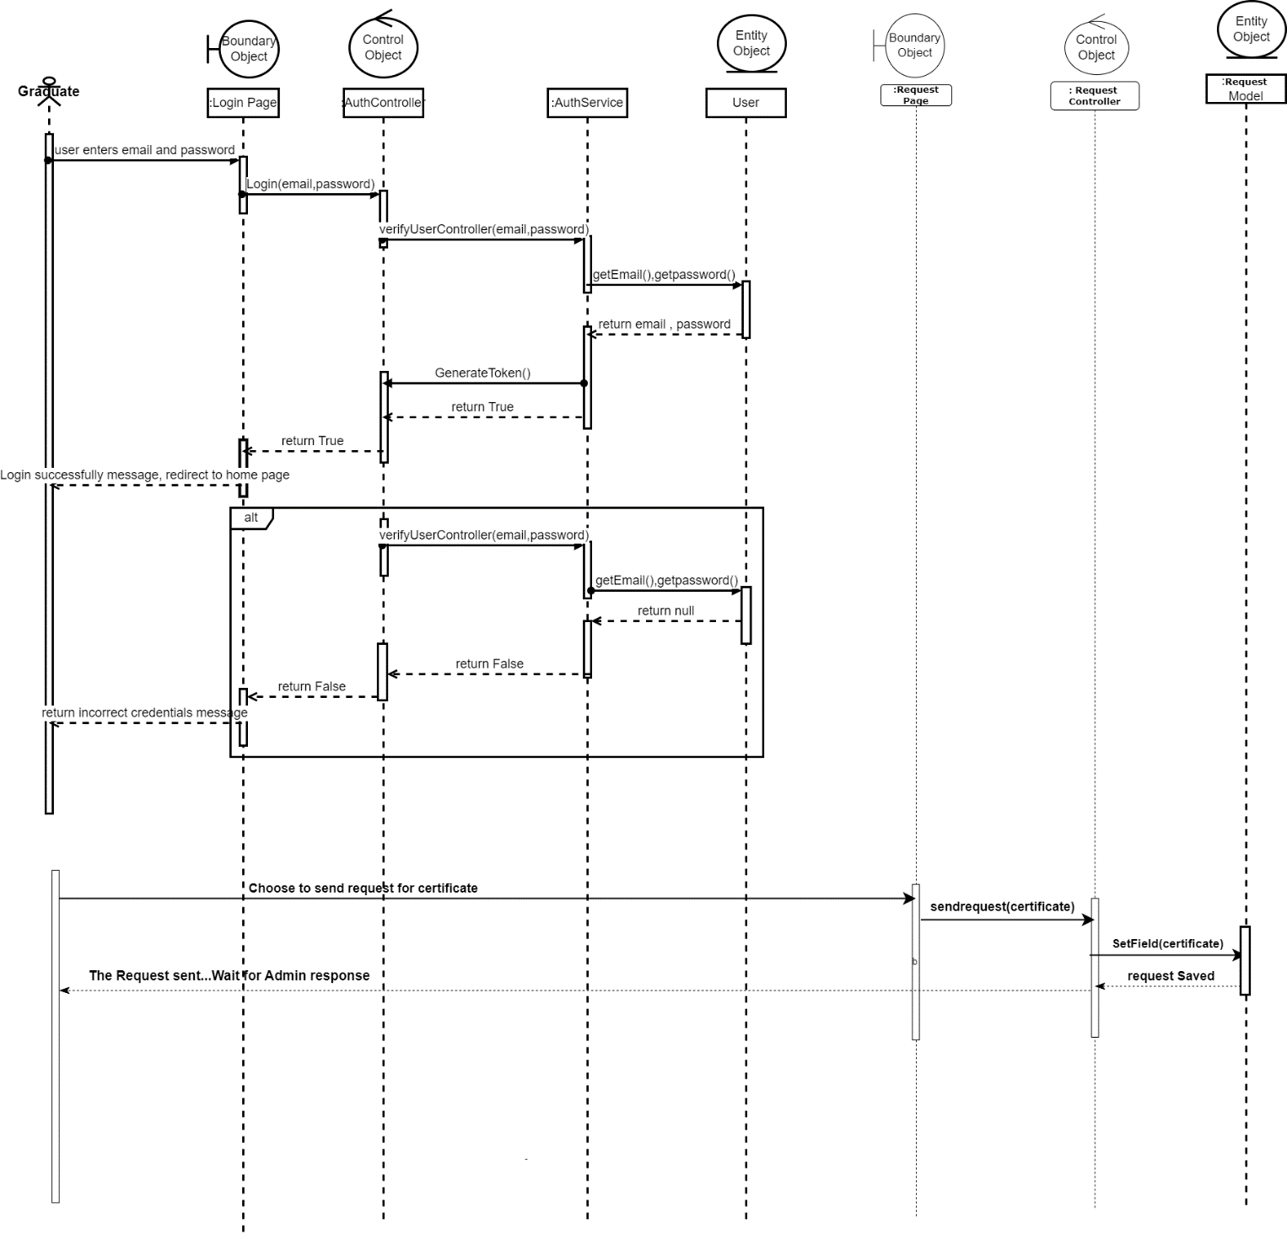**Send a request**

**Search for Graduate**

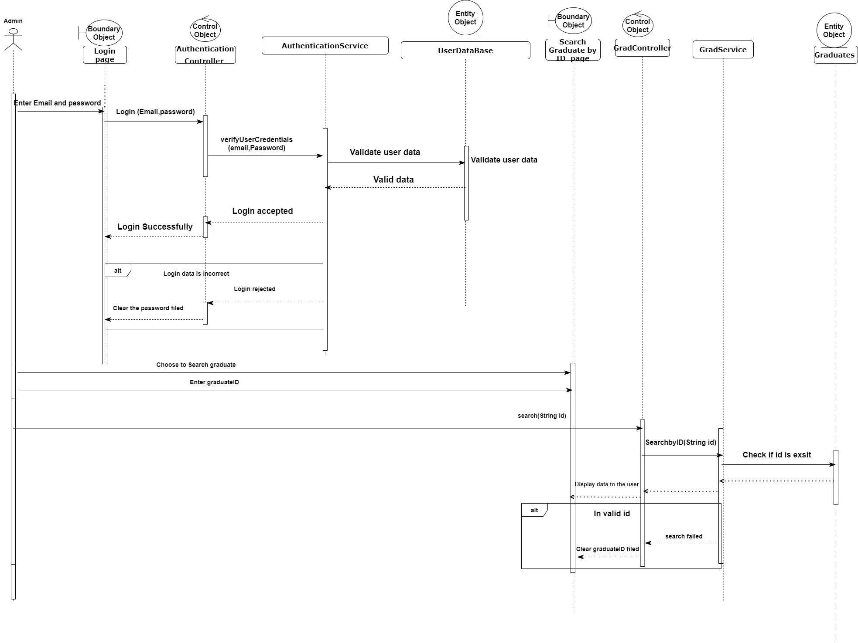

**Activity Diagram**

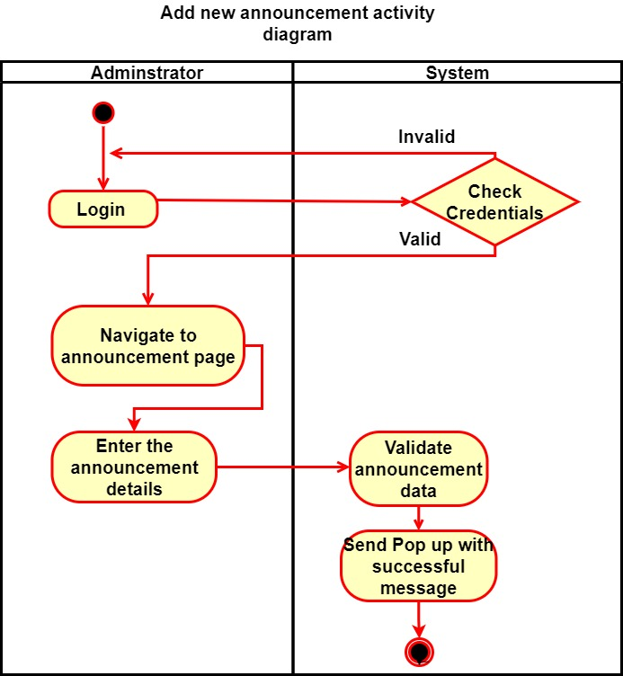

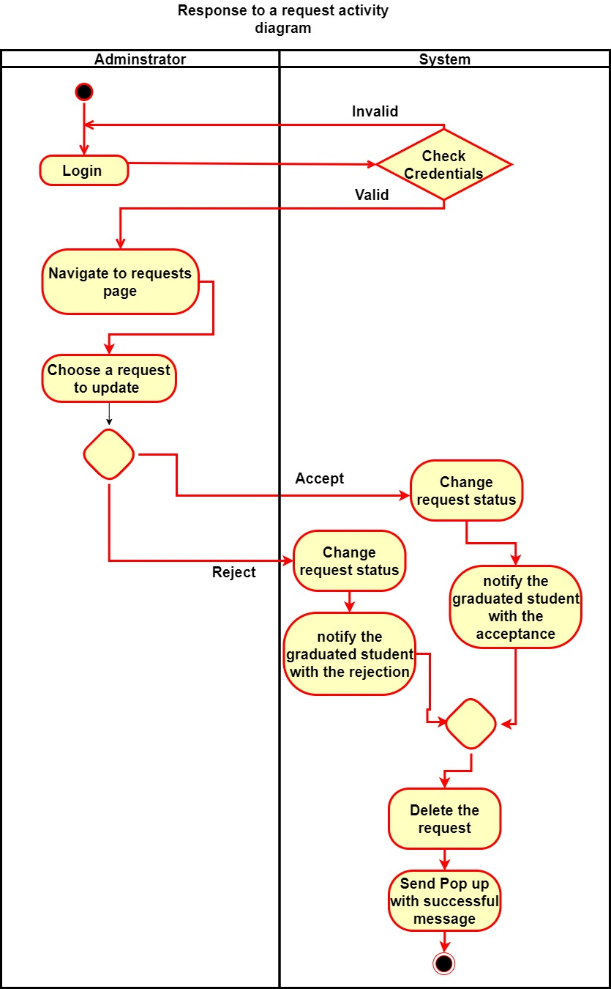

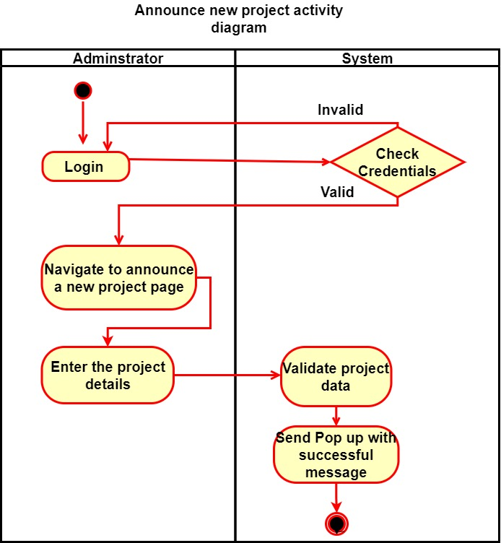

**Print certificate**

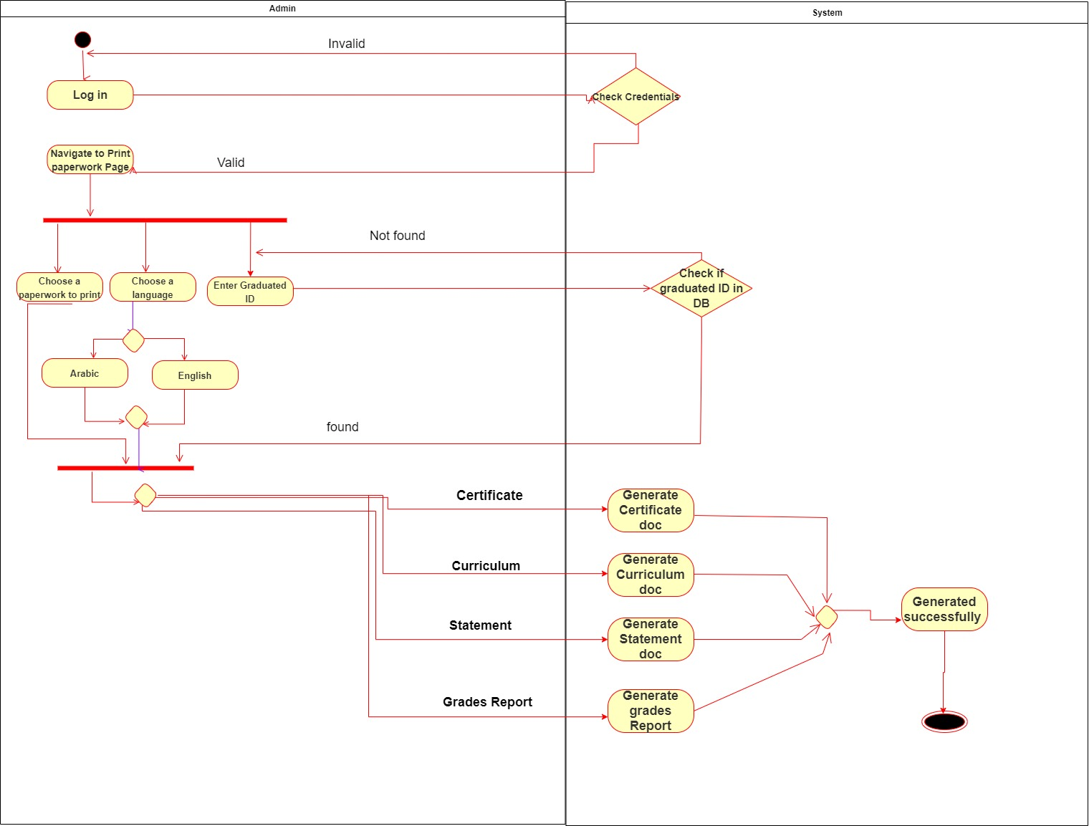

**Add new graduate**

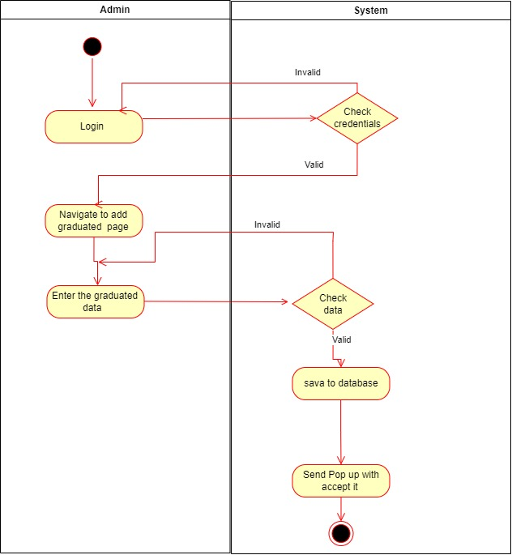

# <graduates guide> Design

**Example Scenario for Admin user**

Login Page

Without entering any inputs, it shows “Email is required”, “Password is required”

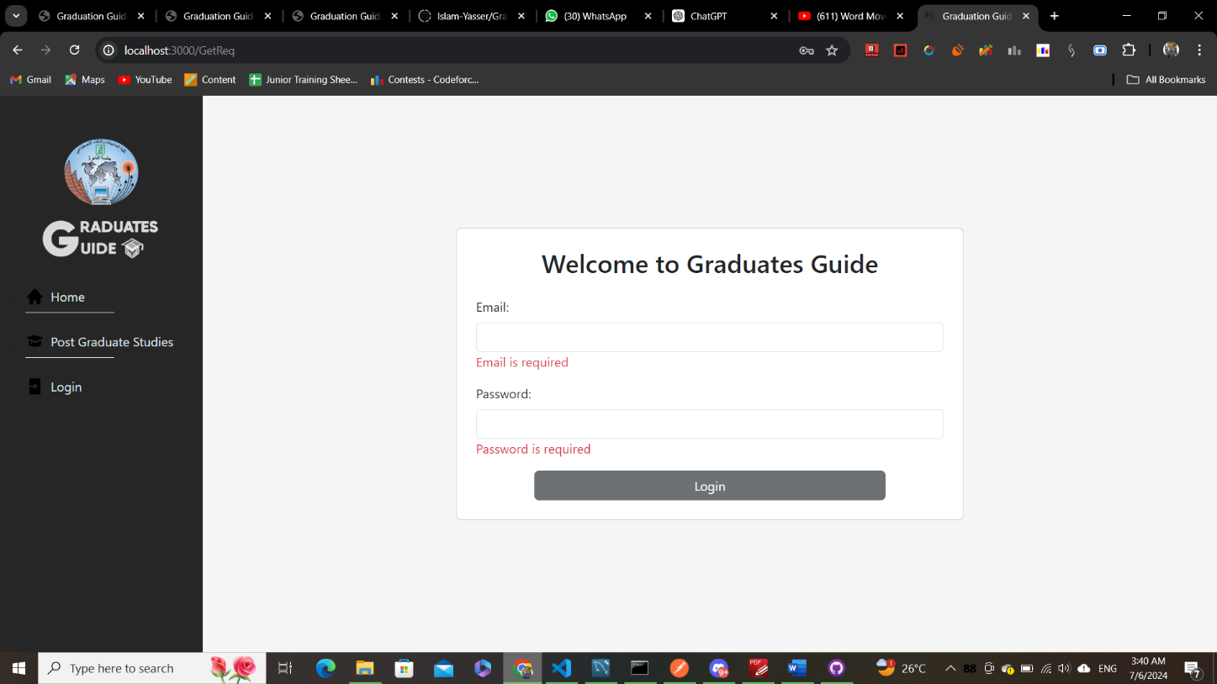

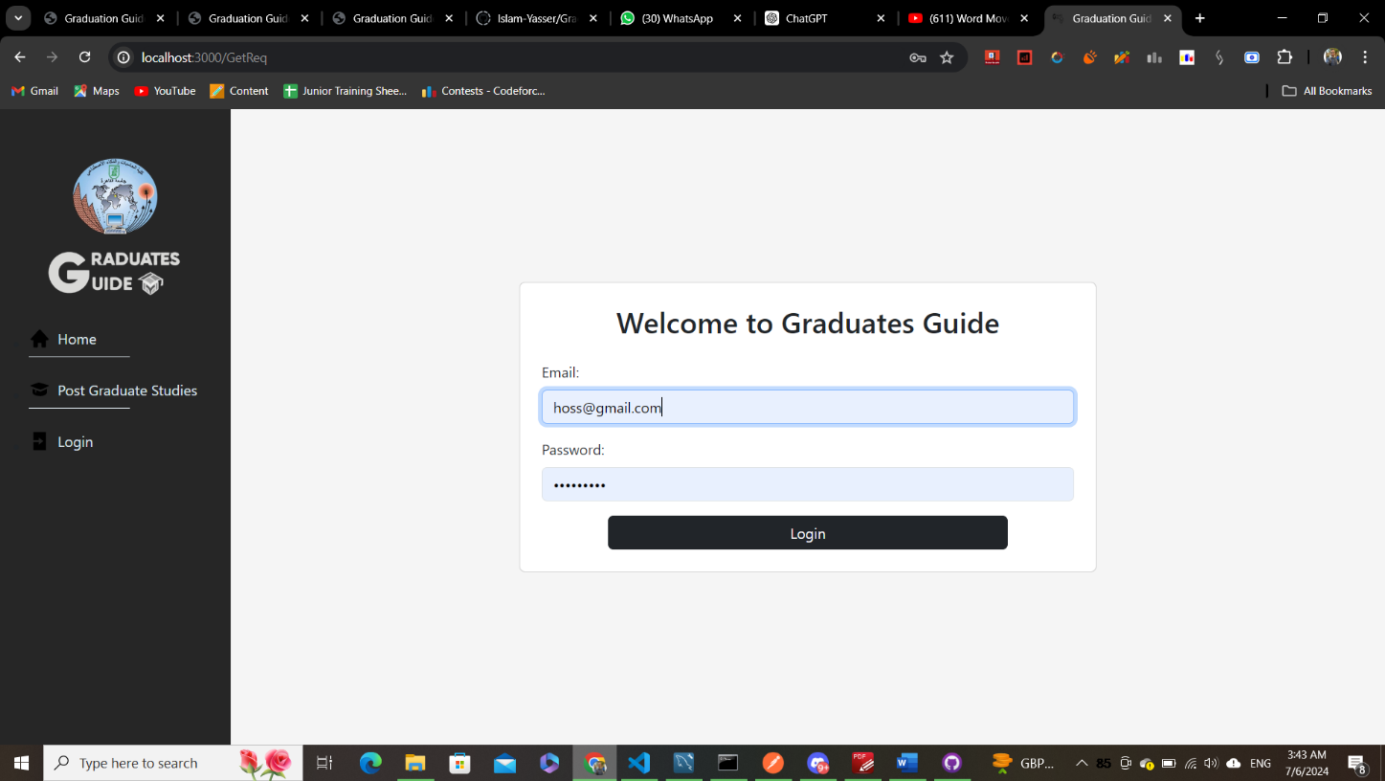After entering inputs

After Clicking Login

It will navigate to the home Page

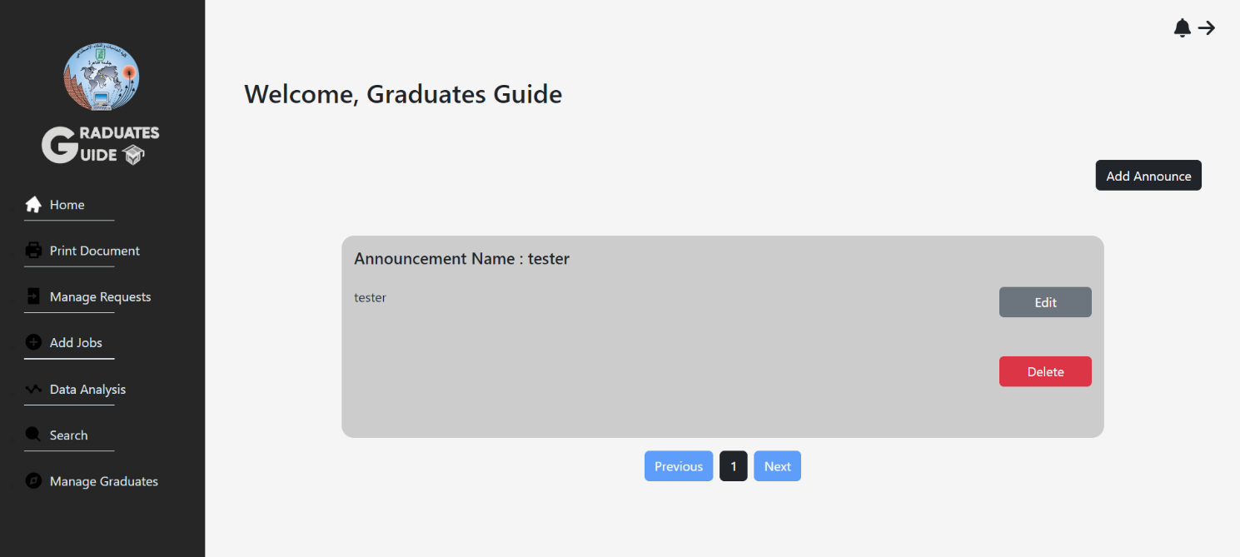The following is the home page for the Admin user with all the functionalities he can perform in the side bar

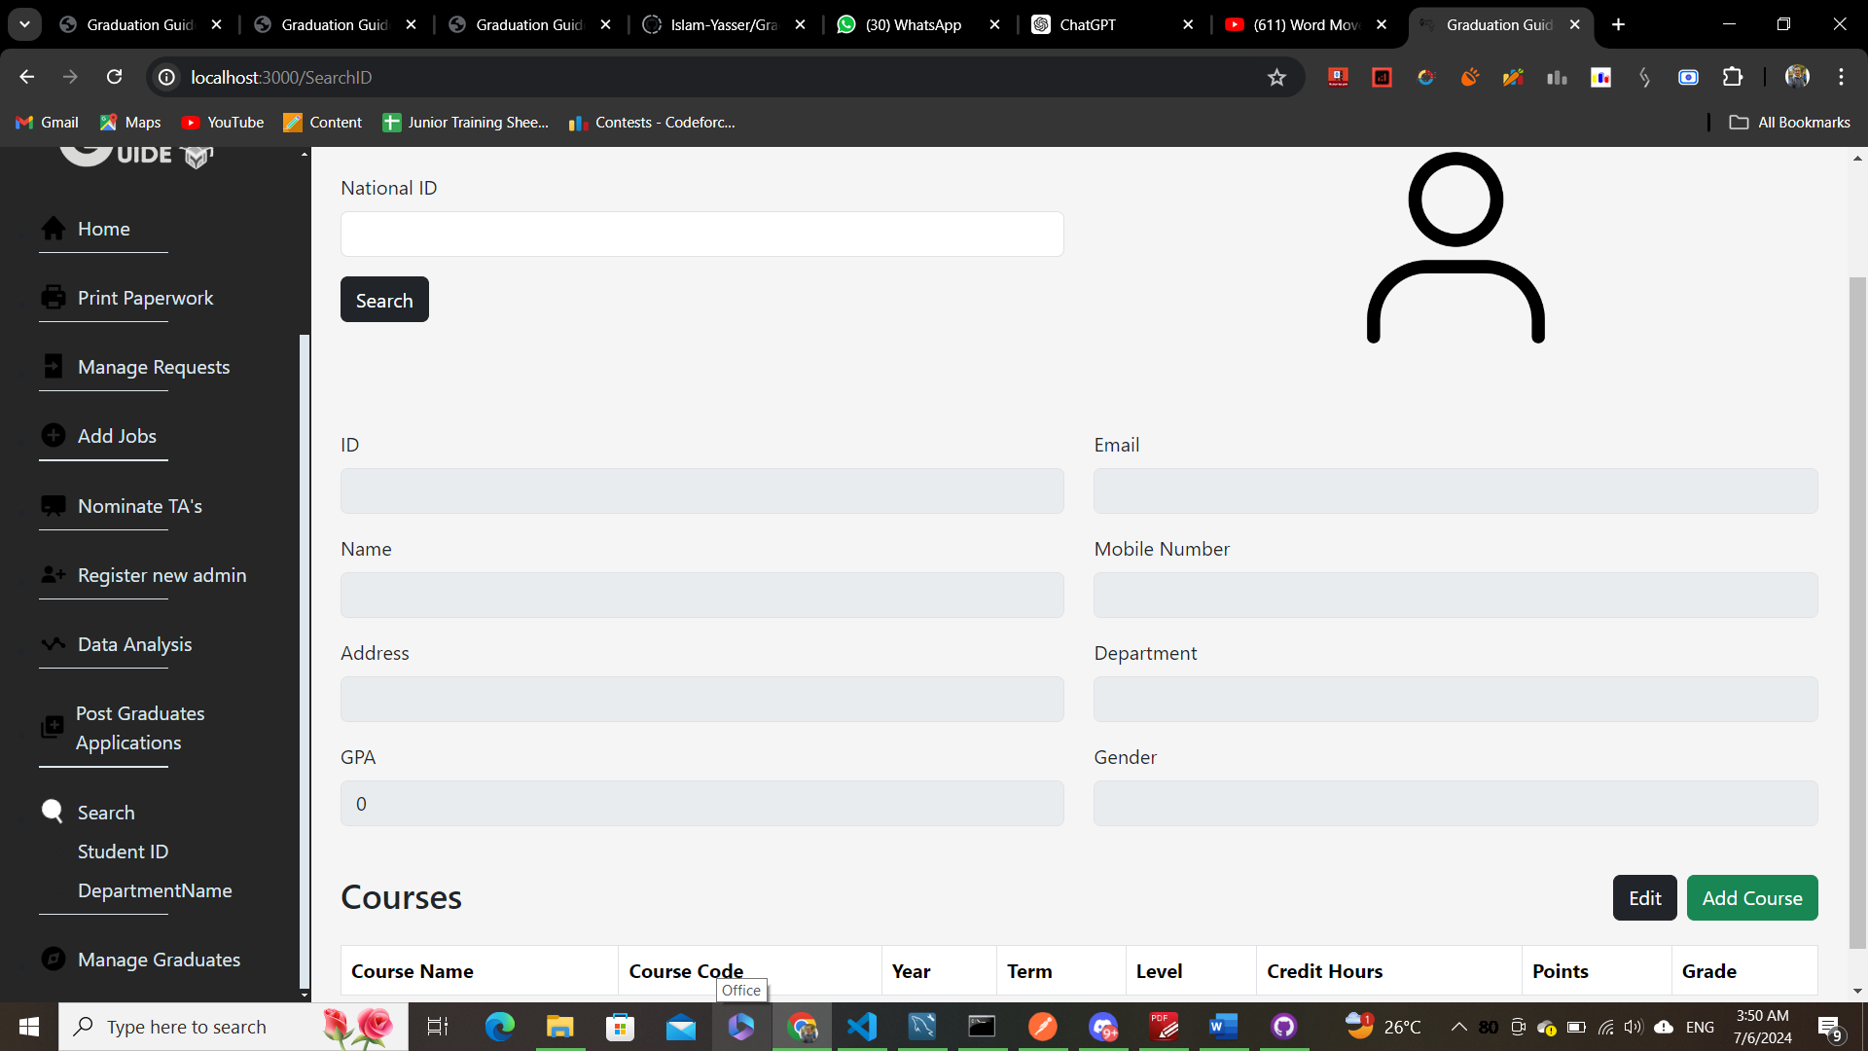

Notice here the search icon is now white

As the Admin clicked Search

from the Side Bar

After Redirecting to the Search Student ID page

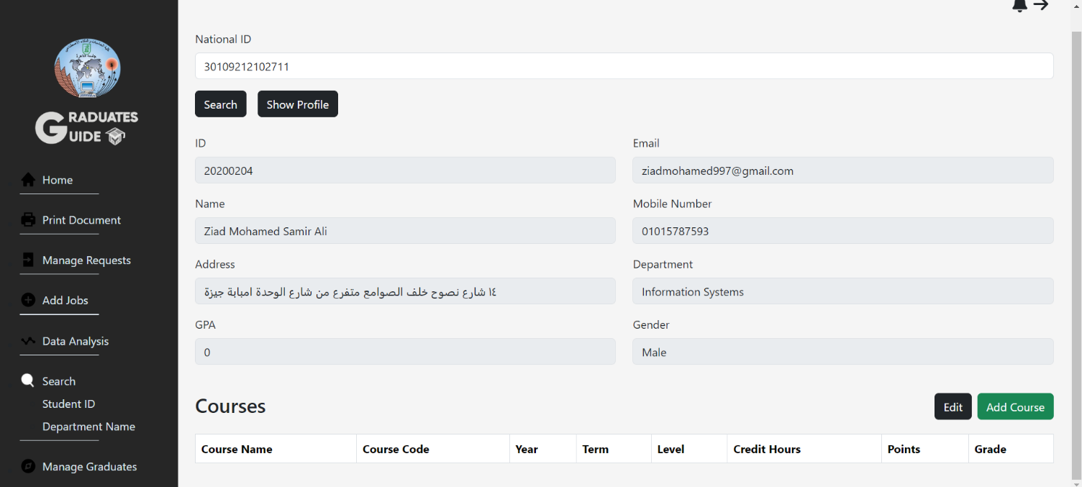And entering a national id the search result shows

The admin can Add Courses by clicking Add Course button

A form to add the course data will open

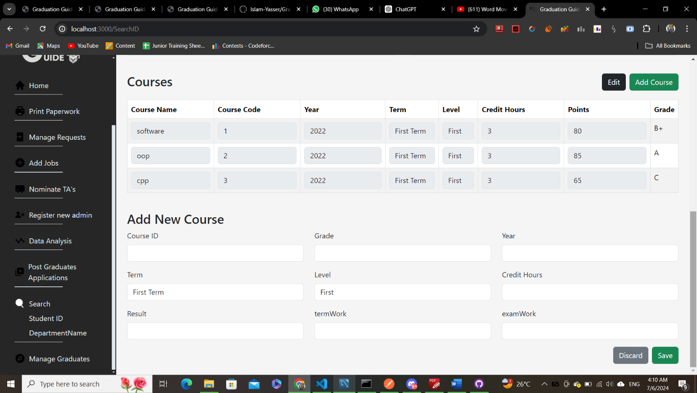

After adding course data and clicking save

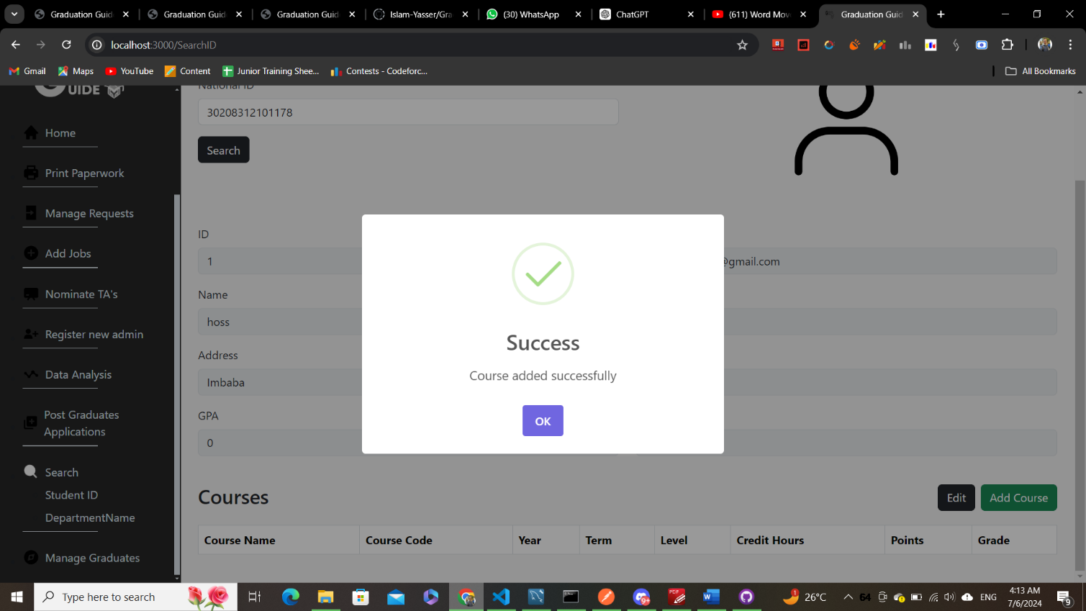This popup message shows

**Moving to Search Department Name page**

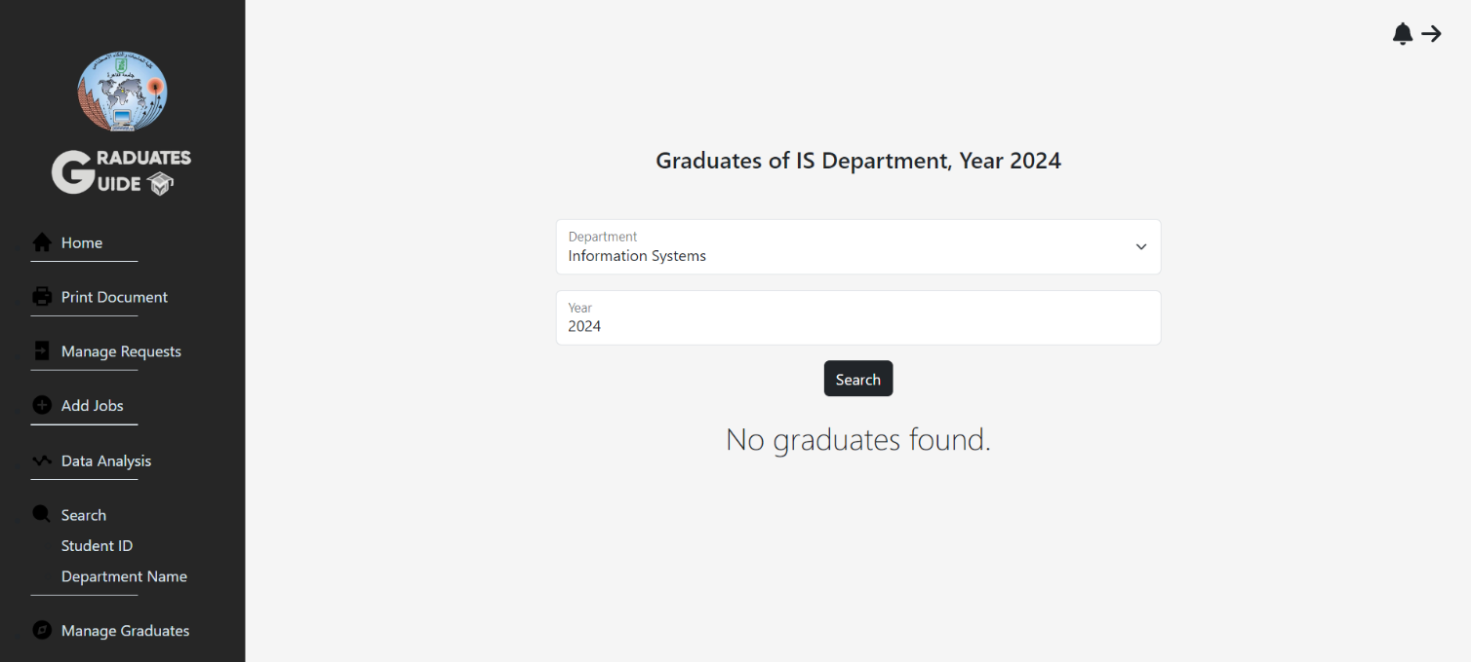

**After entering the department and the year of graduation**

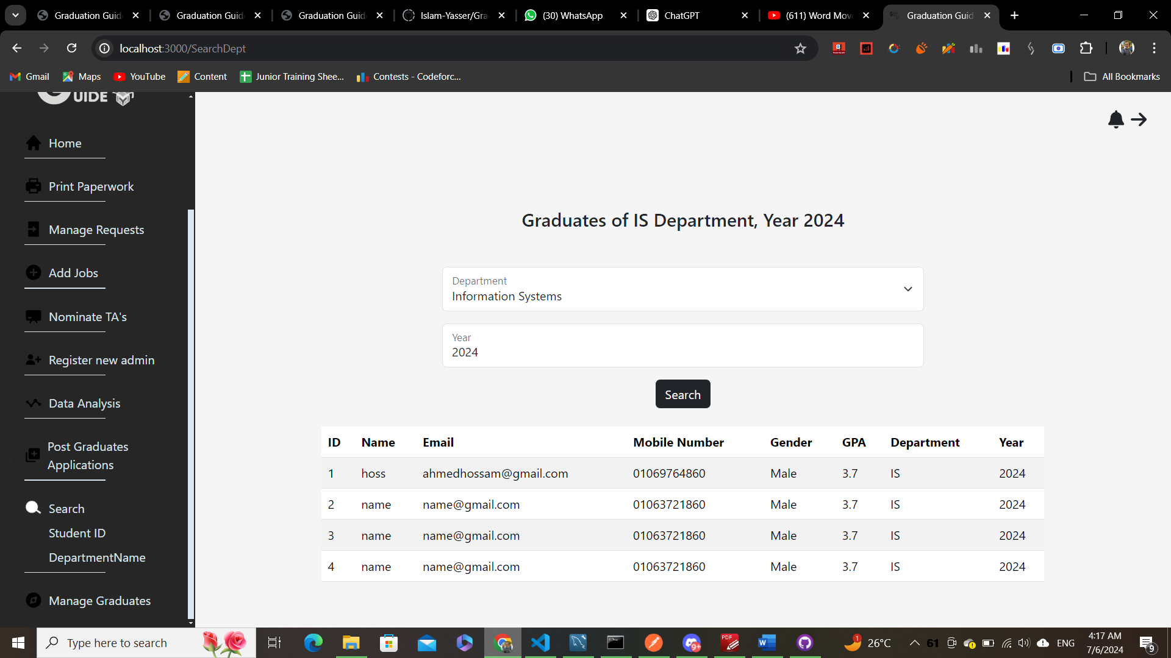**And click search the results show**

**Moving to Manage Request Page**

**It shows all the requests that have been made by graduates**

**And the admin has the choice to accept or reject**

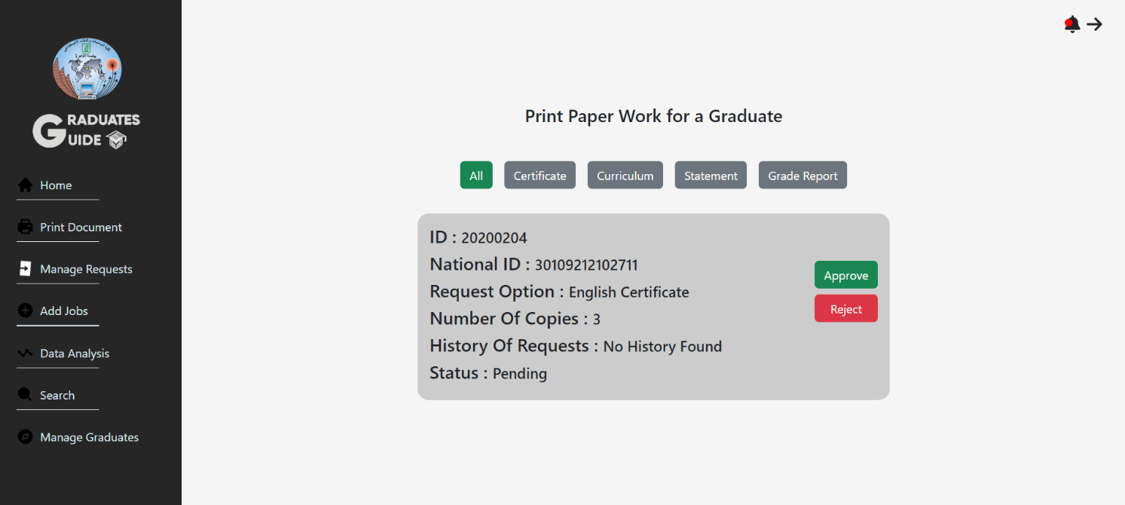

**Moving to Add Job Page**

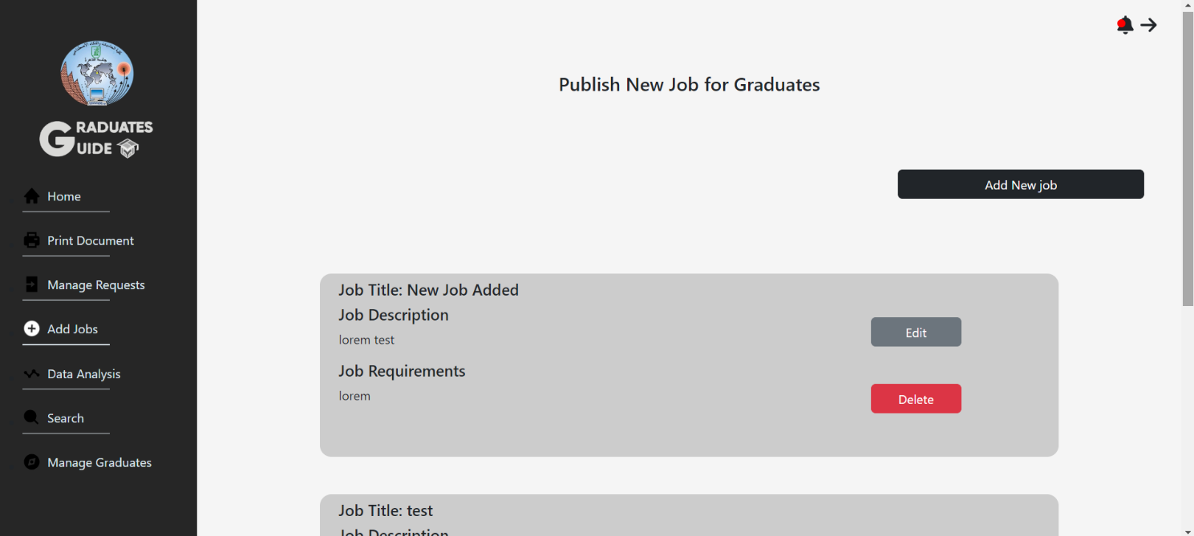**Where the admin can publish a job that will be shown to the graduates**

**after clicking Add Job a Popup form shows to enter**

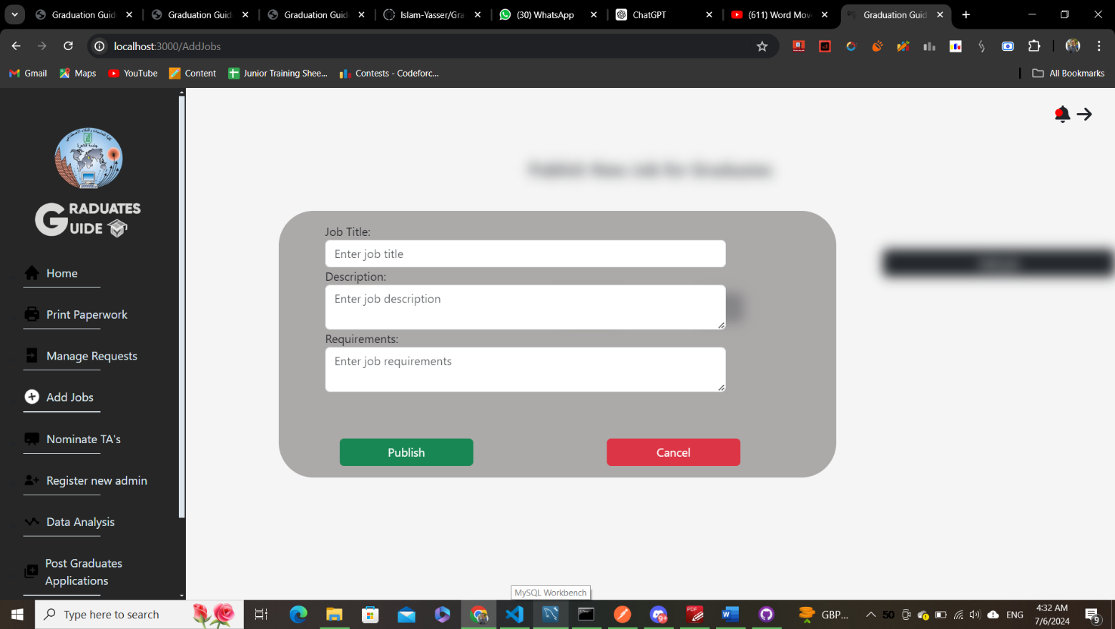**the job details**

**Post Graduates Applications Page**

**Will show any application that has been applied**

**And the Admin has the ability to accept or reject**

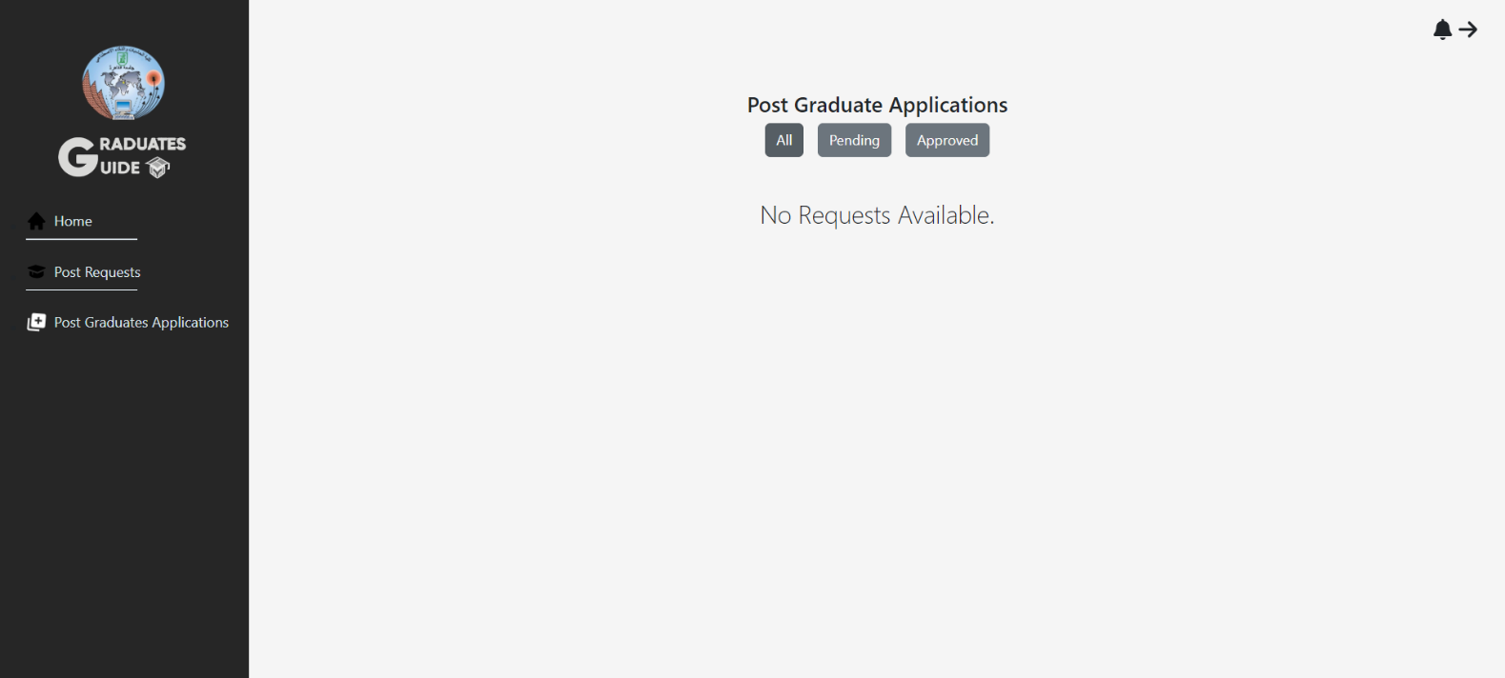

**Data Analysis Page**

**The system performs analysis about how many graduates are employed**

**And how many of them in a local company or international company**

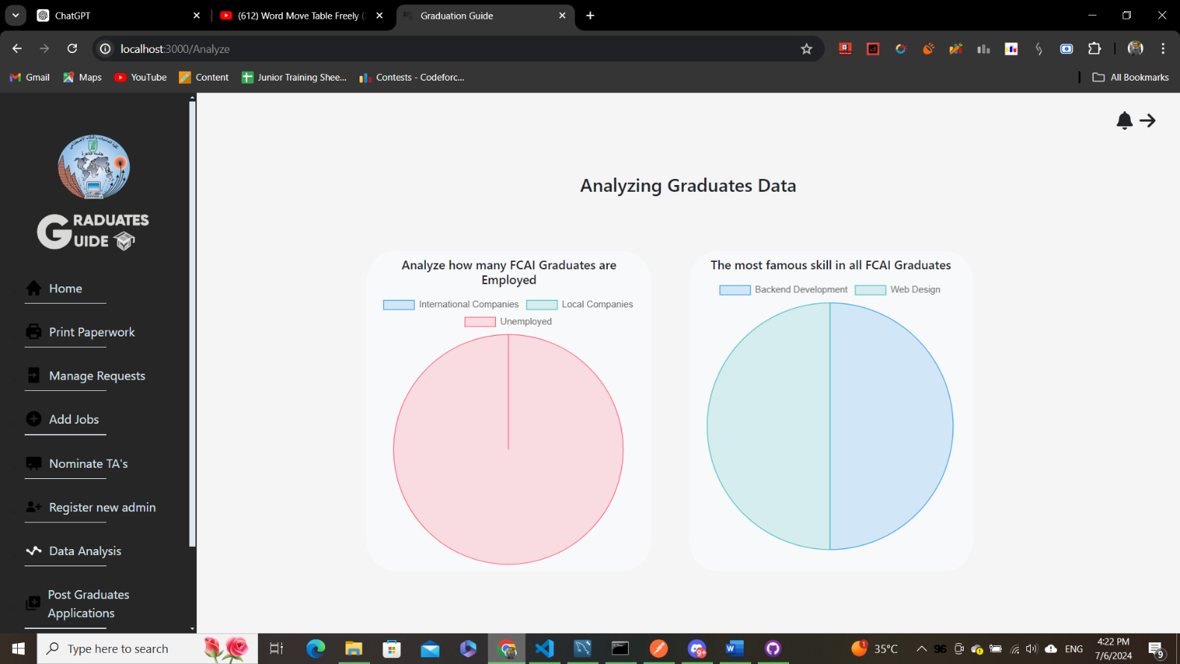**And also displays the most famous skills that the graduates have**

**Here in the home page**

**The admin can publish any announcement**

**And after clicking publish it will be available to the graduates**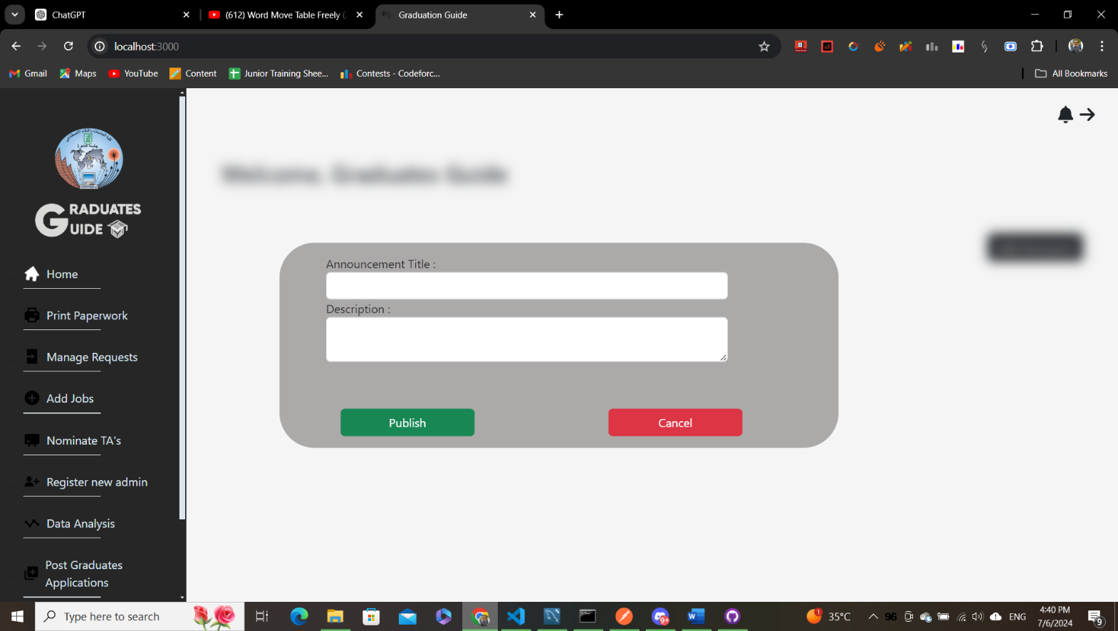

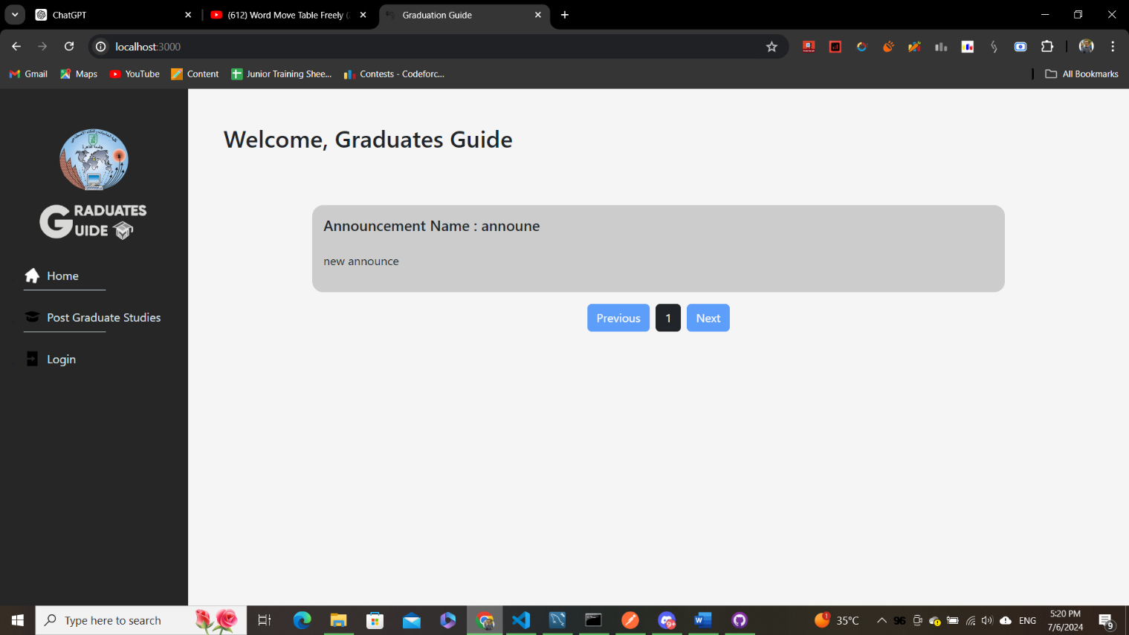**Here is the announcement appears in the home page**

**Moving to add graduate page**

**The admin enters the graduate data and click submit the graduate**

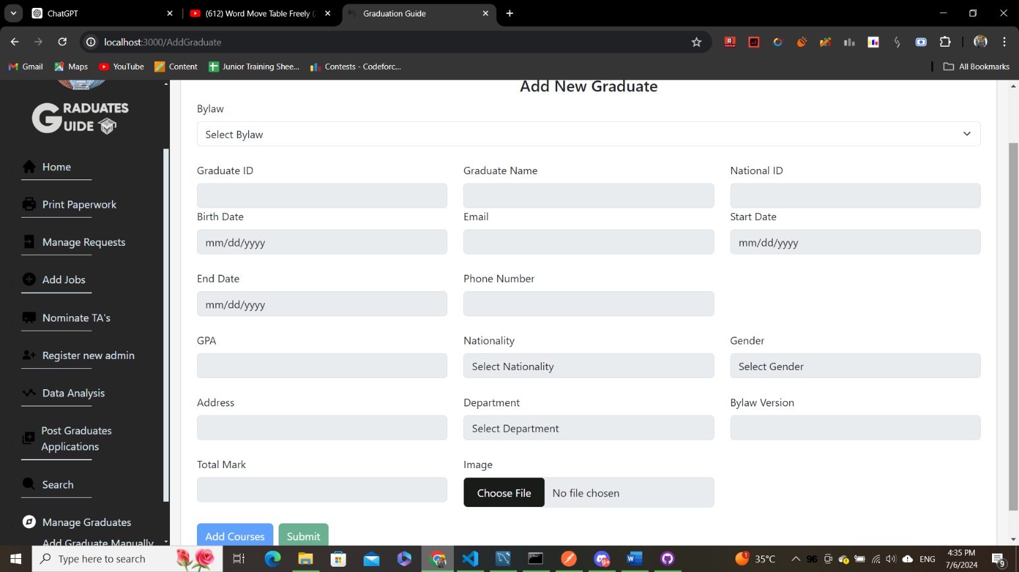**Will be added to the database**

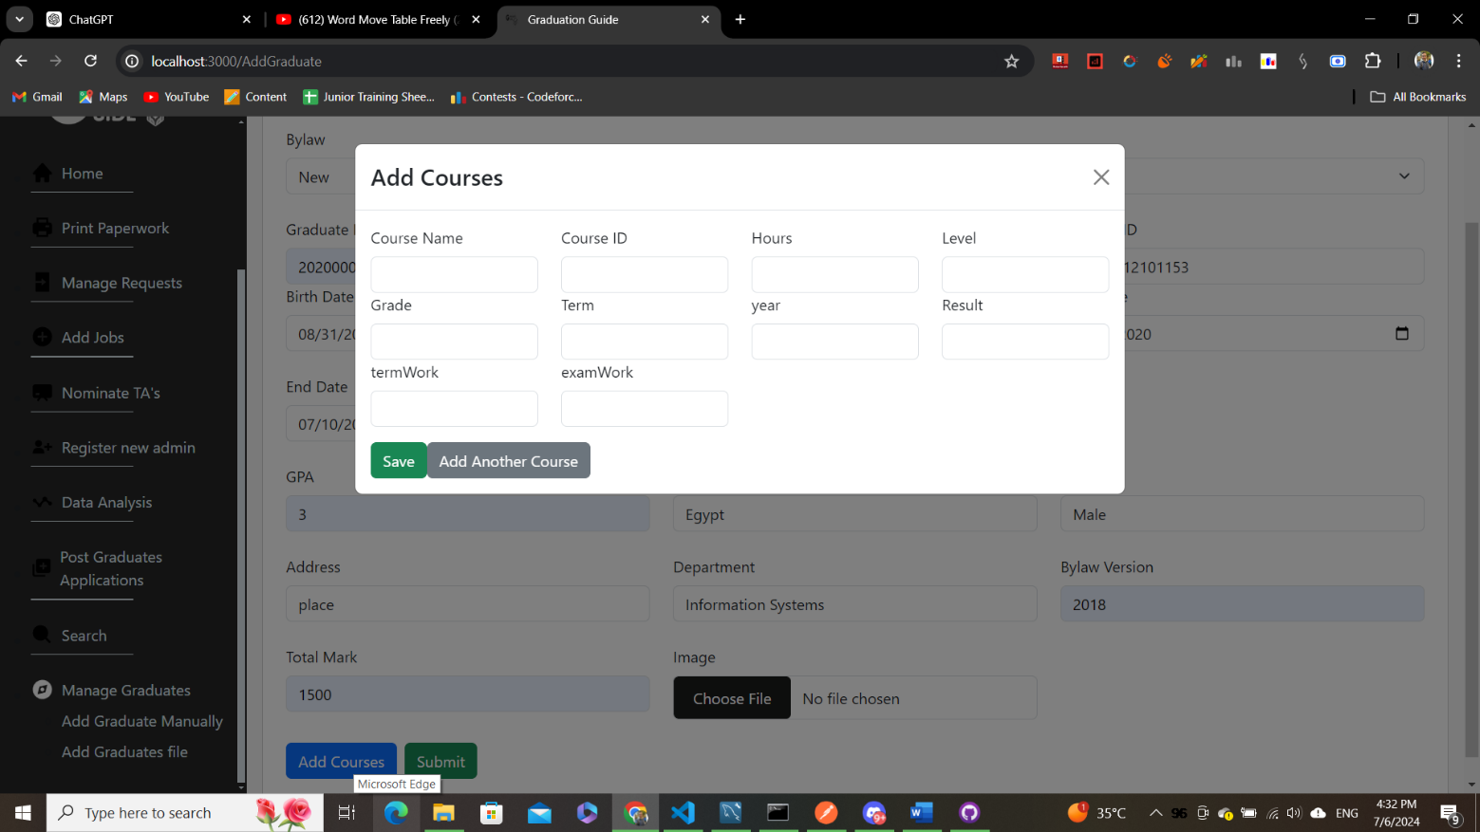**The admin can add courses to the graduate**

**And here is after clicking submit**

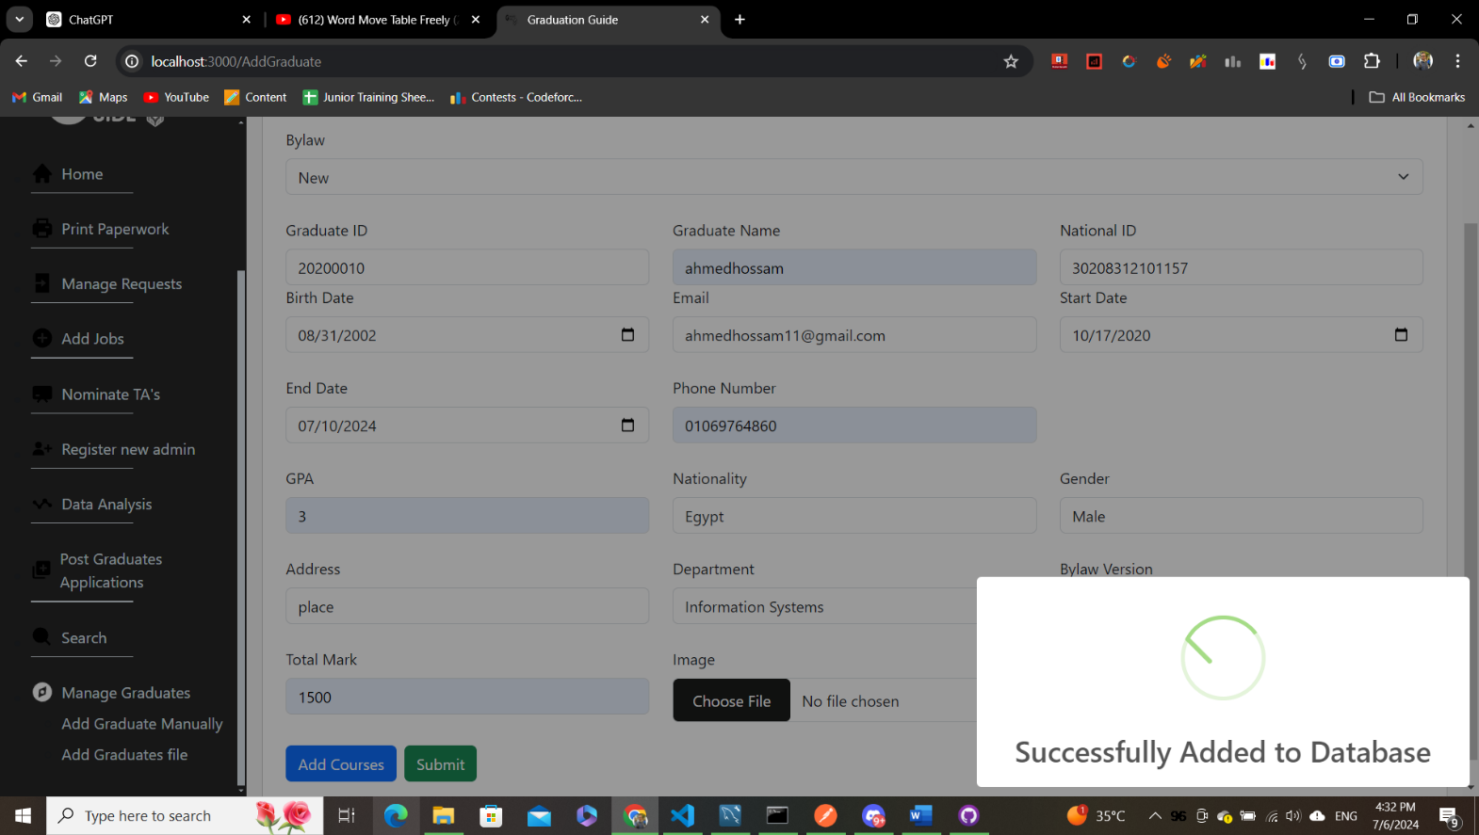

**The following pages related to Post Graduate studies**

**Are available to all users**

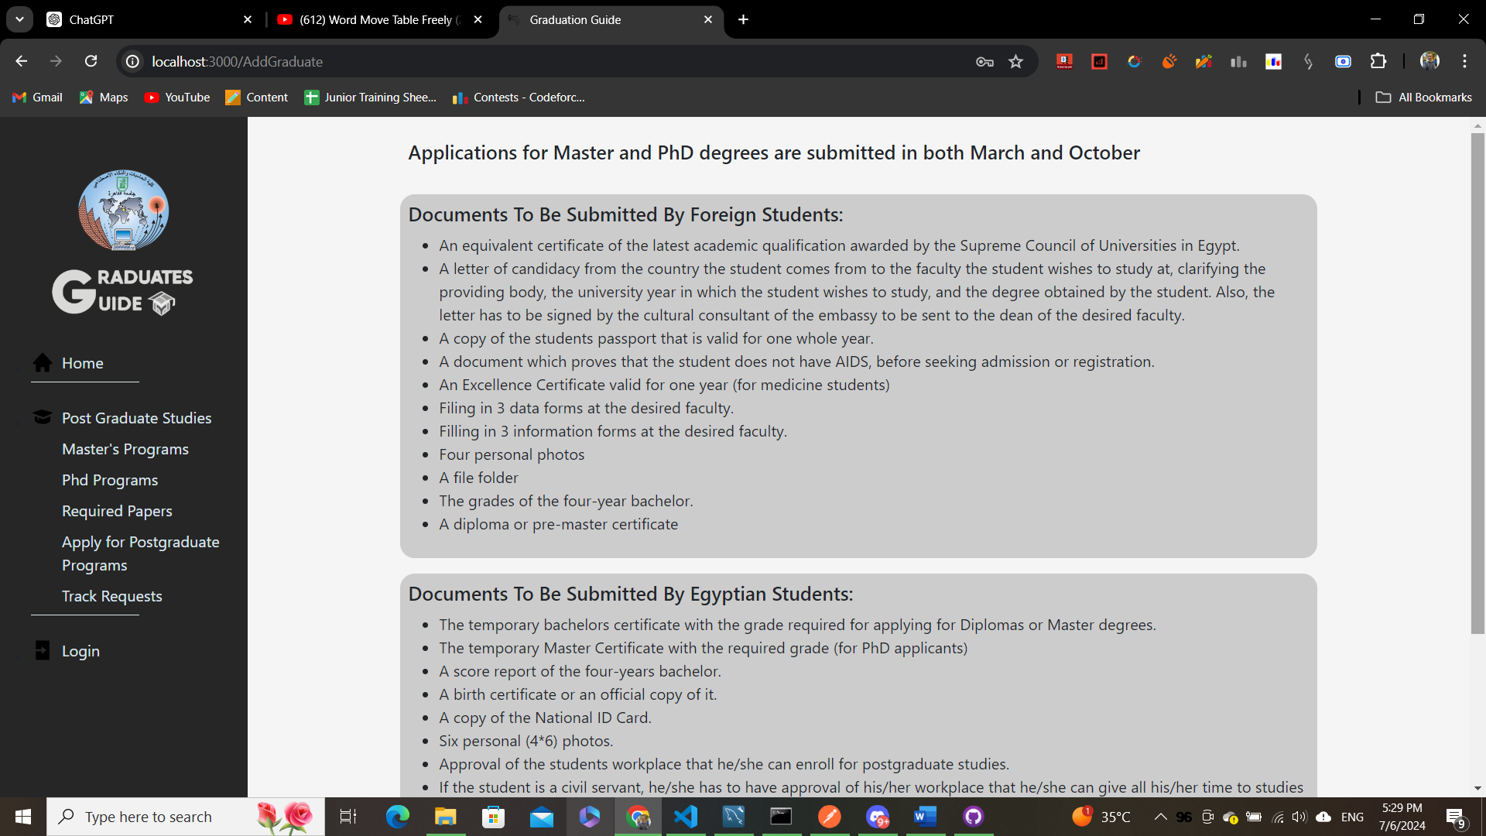

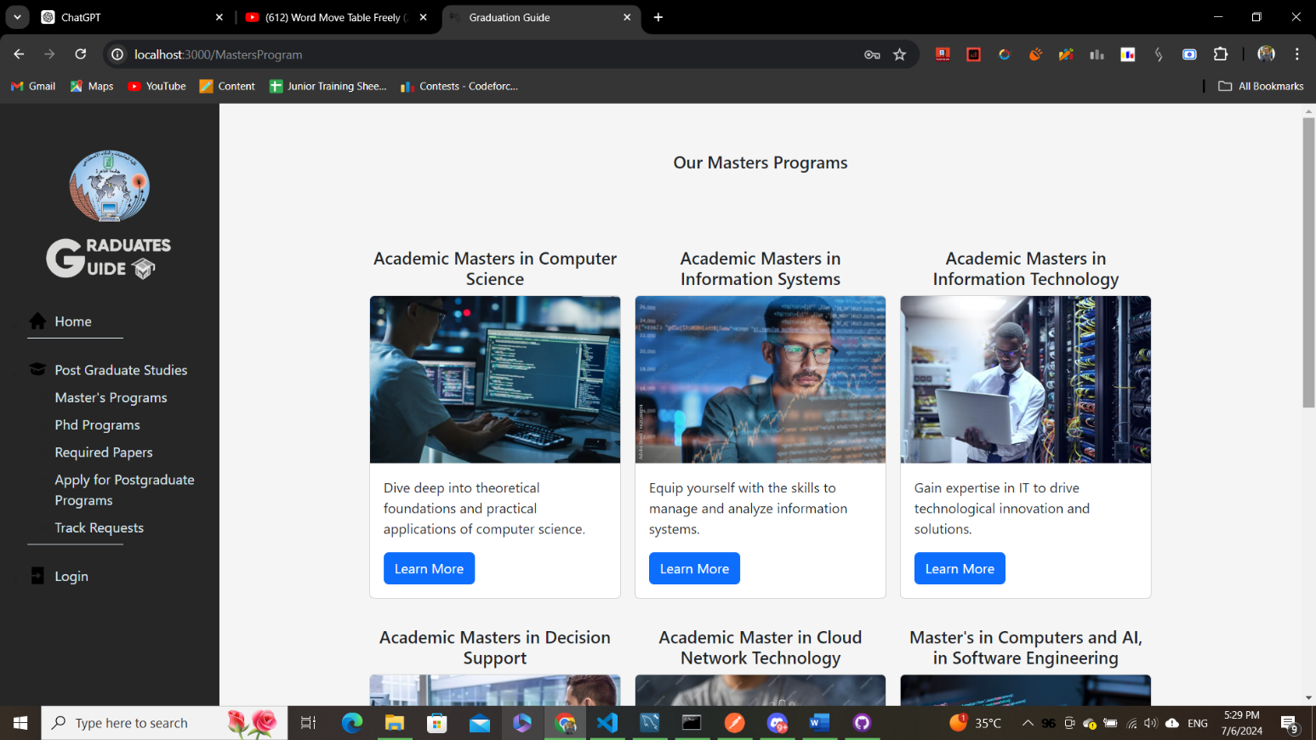

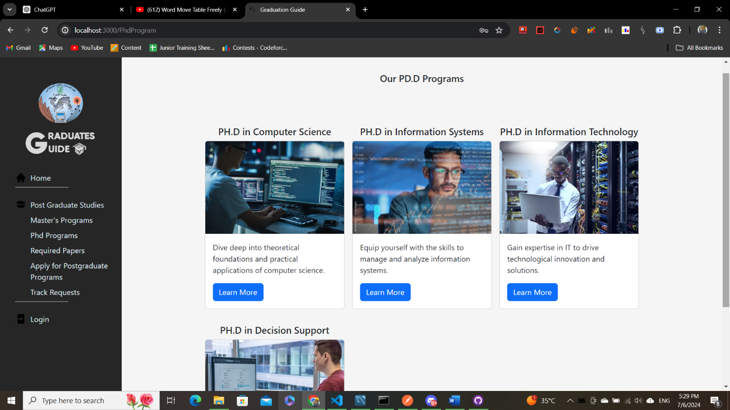

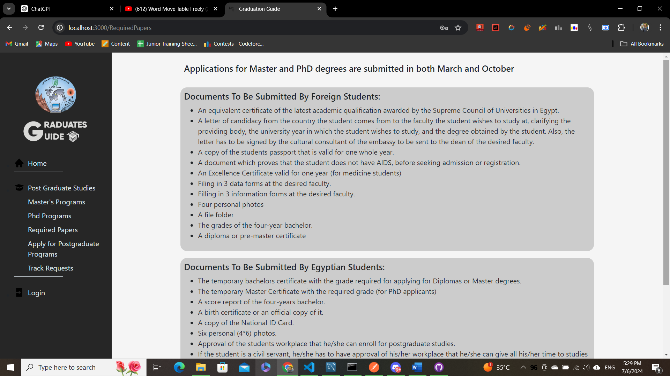

**This is the form to apply to the**

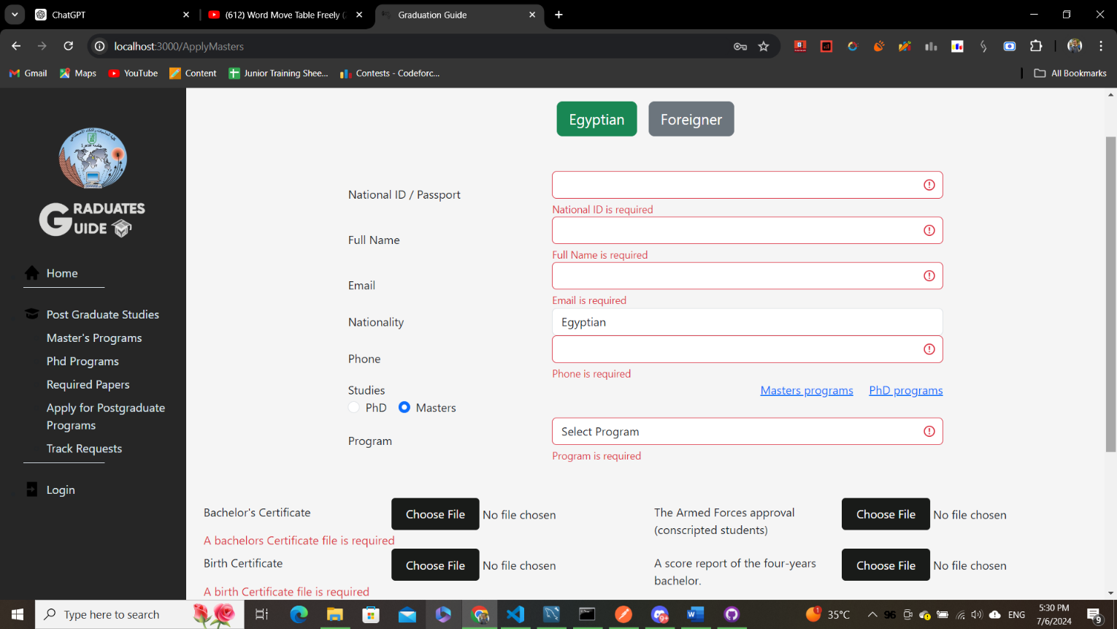**Masters and Phd programs**

**And here anyone applied can track his request**

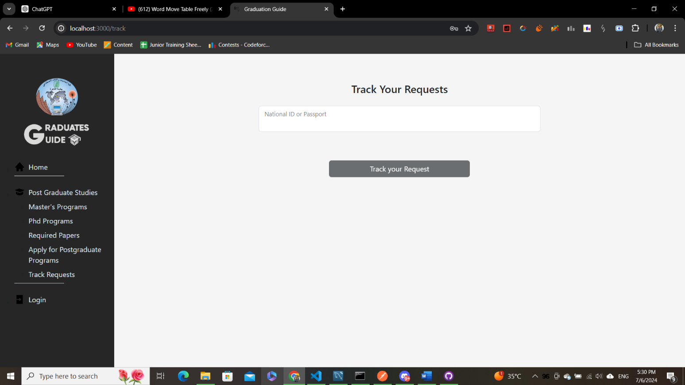**To know the status**

**Example Scenario for Graduate user**

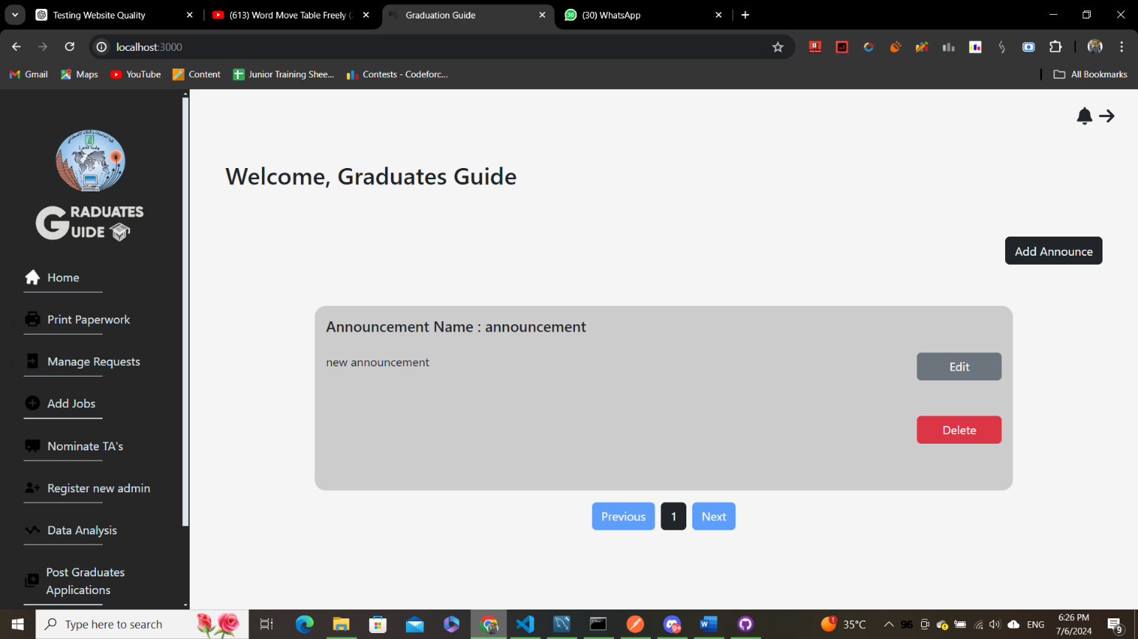**this is the home page contains all the announcements**

**this is the profile page for the graduate**

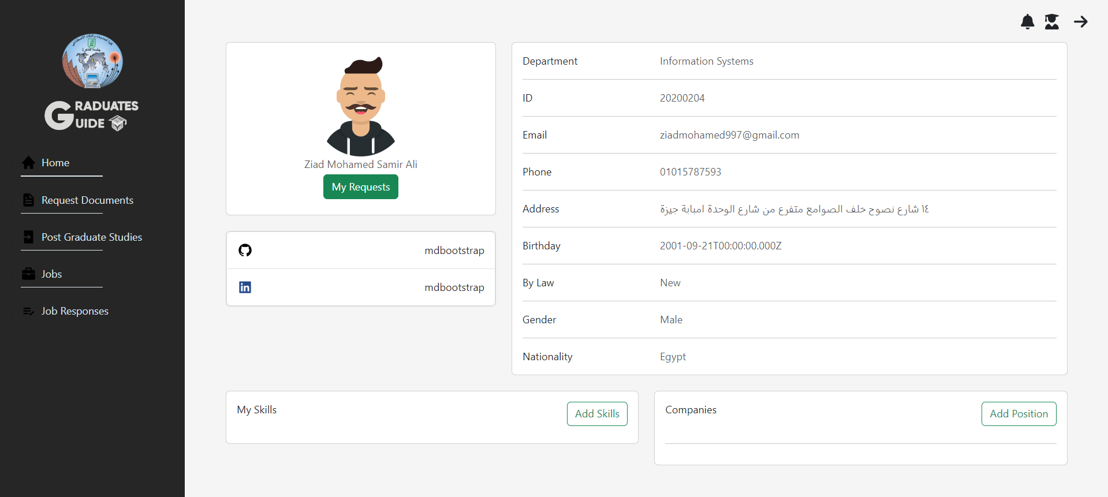**containing all his info**

**the graduate can add skills to his profile**

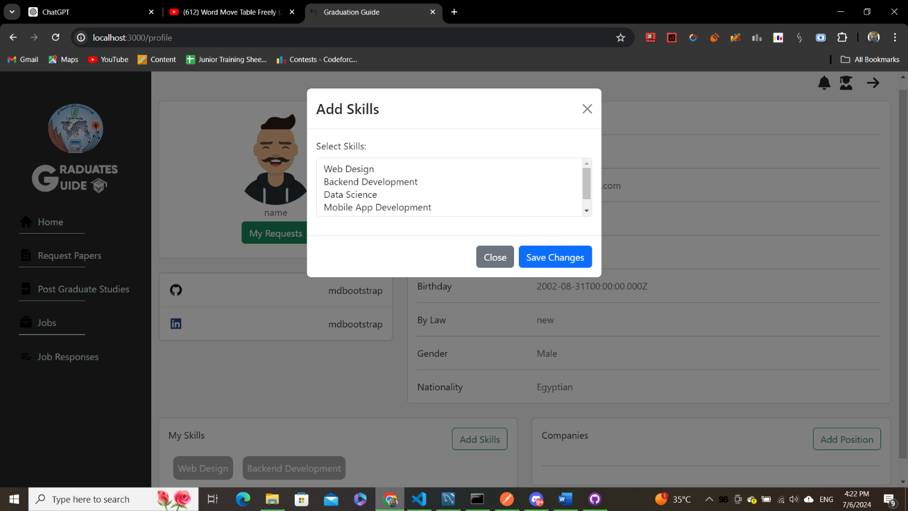

**also, the graduate can add his work experience**

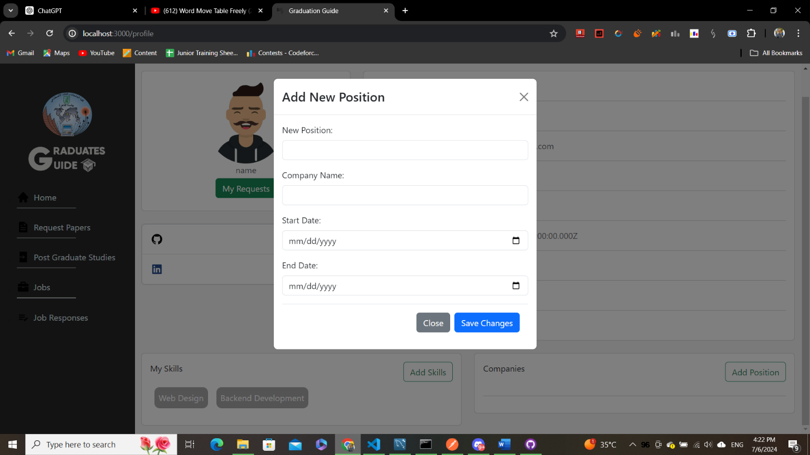

**Request documents page that allows the graduate**

**To request any document or certificate he wants**

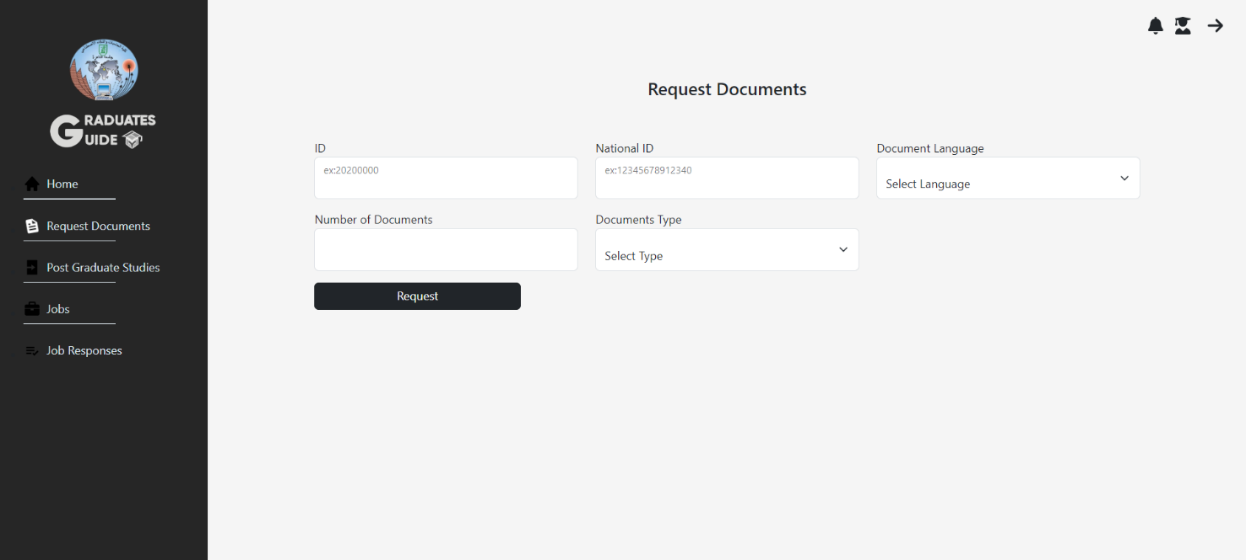

**in this page the graduate will find**

**any response for his job application**

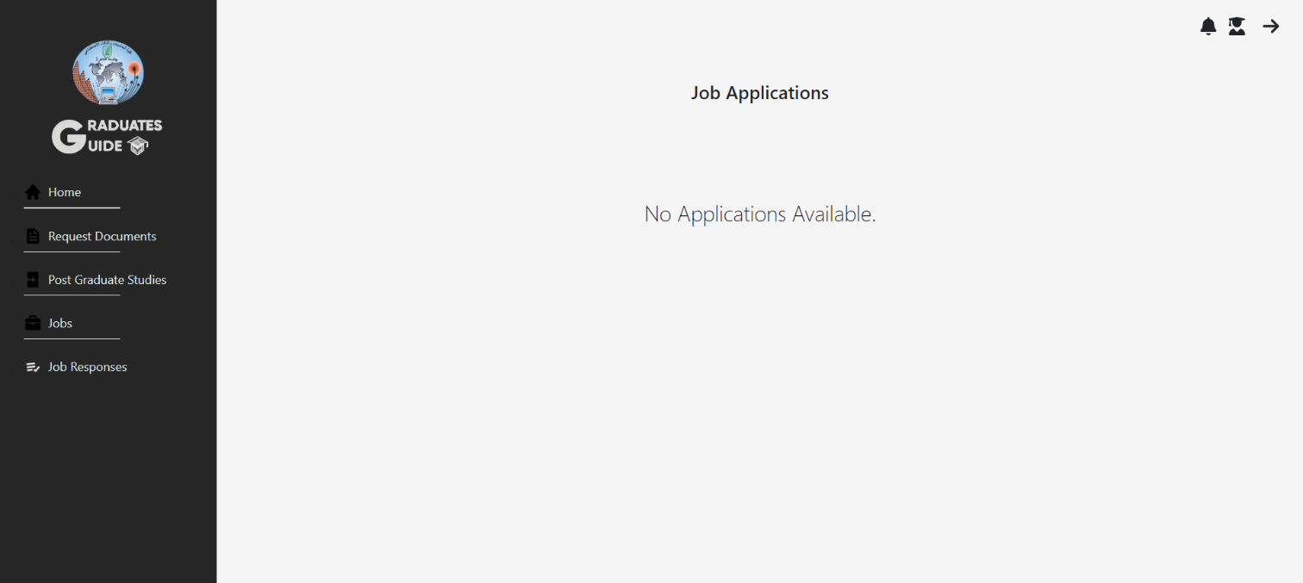

Chapter 5

Graduates Guide Testing and Evaluation

Comprehensive Testing for a Graduates Guide Website

API Testing with Postman:

Endpoint Verification: Use Postman to thoroughly test API endpoints, ensuring they behave as expected.

Input and Output Validation: Check the correctness of inputs and outputs to confirm the API processes requests and responses accurately.

Database Consistency Testing:

Data Integrity: Verify that data is stored and retrieved correctly, ensuring no corruption or loss.

Data Manipulation: Test CRUD operations (Create, Read, Update, Delete) to confirm proper functionality.

Performance Evaluation: Assess the database performance under various loads to ensure it meets the required speed and efficiency.

Website Availability and Response Time:

Load Testing: Evaluate the website's ability to handle expected user loads without degradation in performance.

Response Time Monitoring: Ensure the website responds within acceptable timeframes to maintain a good user experience.

System Functionality Testing:

End-to-End Testing: Test the entire system to ensure all components work together seamlessly.

Output Verification: Confirm that the system provides the correct and desired outputs for various scenarios.

By implementing these testing strategies, we can ensure that the Graduates Guide Website is reliable, efficient, and provides a positive user experience.

|  |  |  |  |  |  |
| --- | --- | --- | --- | --- | --- |
| **#** | **Functionality** | **Test Case** | **Input** | **Expected Output** | **Test Result** |
| **1** | **Login**  **(All users)** | **1.1** | Login with valid email and password | Navigate to home  page | Pass |
| **1.2** | login with invalid email | Invalid Email address | Pass |
|  |  | **1.3** | login with invalid password | Wrong Password | Pass |
| **1.4** | Empty Input | Email is required  Password is required | Pass |
| **2** | **Register New admin**  **(Super Admin)** | **2.1** | Empty Inputs | Name is required,  Email is required,  Password is required,  Role is required | Pass |
| **2.2** | Set invalid name or email or password | Failed to register new admin | pass |
| **2.3** | Set valid name and email and password and role | Admin registered successfully | Pass |
| **3** | **Add Graduate**  **Manually**  **(Admin)** | **3.1** | Empty Input | All fields are required | Pass |
| **3.2** | invalid data | National Id must match birthdate,  Mobile number must be of 11 numbers,  Email must be a valid email,  Course doesn’t exist | Pass |
| **3.2** | Enter valid data for both courses and graduate | Graduate added  successfully | Pass |
| **4** | **Search for Graduate by National ID**  **(Admin)** | **4.1** | Empty field | National Id required | Pass |
| **4.2** | Valid National Id | Graduate doesn’t exist | Pass |
| Graduate retrieved successfully |
| **5** | **Add Graduates from file**  **(Admin)** | **5.1** | Empty Input | All fields are required | Pass |
| **5.2** | All rows are accepted | File uploaded and graduates added successfully | pass |
| **5.3** | invalid data | National Id must match birthdate,  Mobile number must be of 11 numbers,  Email must be a valid email,  Course doesn’t exist | Pass |
| **6** | **Request Doc.**  **(Graduate)** | **6.1** | Empty input | All fields are required | Pass |
| **6.2** | Valid input | Graduate doesn’t exist | Pass |
| Your request has been sent successfully |
| **7** | **Apply for Job**  **(Graduate)** | **7.1** | No file uploaded | File is required | Pass |
| **7.2** | File is uploaded | Application sent successfully | Pass |
| **8** | **Apply for Masters and PhD**  **(Applicant)** | **8.1** | Empty input | All fields are required | Pass |
| **8.2** | All input was entered | Application sent successfully | Pass |
| **9** | **Track your request**  **(Applicant)** | **9.1** | Empty input | National id is required | pass |
|  |  | **9.2** | Correct national id entered | no requests for that national id | pass |
| Requests are displayed |
| **10** | **Add Skills**  **(Graduate)** | **10.1** | Choosing skills and click save | Skills are added successfully | pass |
| **11** | **Add Position**  **(Graduate)** | **11.1** | Empty input | All fields are required | pass |
|  |  | **11.2** | All fields are filled | Position added successfully | pass |
| **12** | **Publish announcement**  **(Admin)** | **12.1** | Empty input | All fields are required | pass |
|  |  | **12.2** | All fields are filled | announcement published successfully | Pass |
| **13** | **Print documents**  **(Admin)** | **13.1** | Empty input | All fields are required | pass |
|  |  | **13.2** | All fields are filled | Graduate wasn’t found | pass |
| Graduate found and document is downloaded |
| **14** | **Publish Job**  **(Admin)** | **14.1** | Empty input | All fields are required | pass |
|  |  | **14.2** | All fields are filled | Job published successfully | pass |
| **15** | **Nominate TA**  **(Super Admin)** | **15** | Choose a department | Top 15 of the past 2 years are displayed | pass |
| **16** | **Search by department**  **(Admin)** | **16.1** | Empty input | All fields are required | pass |
|  |  | **16.2** | All fields are filled | Search result appear | pass |

Chapter 6 Conclusions and Future Work

Conclusion

The Graduates guide website is a big step forward in improving how things work for graduates and the postgraduate studies department. By combining the old and new bylaws graduates in the same system, the system makes rules clearer and simpler, removing confusion from having separate systems. The new features help faculty administrators do their jobs more easily and give graduates tools to apply for jobs, request documents, and manage their academic records online without needing to visit the faculty. The system also provides a special platform for the postgraduate studies department to handle PhD and master's applications efficiently. This upgrade creates a more organized, user-friendly, and integrated environment for everyone involved.

Future Work

1. Expand the website to be applicable to all faculties in all universities
2. Include the students’ affairs in the system to handle students before and after graduation
3. Adding chat feature to allow communication between graduates